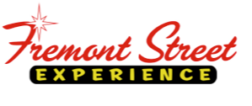

FOR IMMEDIATE RELEASE

Old Dominion and Sawyer Brown to Headline
30th Annual Downtown Hoedown at Fremont Street Experience

Celebrate Wrangler National Finals Rodeo with 12 days of country
kicking off on November 30

Click to Tweet (http://ctt.ec/8I3C3): @OldDominion and @SawyerBrownLive to headline @FSELV's 30th Annual #DowntownHoedown w/ FREE performances on 11/30. #countrymusic #vegas #NFR

LAS VEGAS, NV – October 13, 2016 – Fremont Street Experience is excited to announce that Old Dominion and Sawyer Brown will headline the 30th Annual Downtown Hoedown, the official kick-off to Wrangler National Finals Rodeo week in Las Vegas. The free event takes place on Wed. Nov. 30 and features top country talent beginning at 4:30 p.m. and ending with headliner performances from Sawyer Brown at 8:40 p.m. on the 1st Street Stage and Old Dominion at 9:50 p.m. on the 3rd Street Stage.

“Fremont Street Experience is thrilled to host the official kick-off to Wrangler NFR week with Las Vegas’ largest block party celebrating country music with performances from Nashville’s biggest acts like Old Dominion and Sawyer Brown,” said Patrick Hughes, CEO and president of Fremont Street Experience. “And the fun continues! During the 12 days of Country, we invite everyone to come down for a few drinks and nightly entertainment from country artists that will make sure you continue to have a boot scootin’ good time after the rodeo festivities have ended.”

The 30th Annual Downtown Hoedown is the official kick-off event to the Wrangler NFR and the start of 12 Days of Country at Fremont Street Experience, featuring free nightly performances from country artists to coincide with Wrangler NFR week from Nov. 30-Dec.11. Previous performers at the annual Downtown Hoedown include hit artists like: Thomas Rhett, LoCash, Chris Janson, Cole Swindell, Joe Diffie, Montogomery Gentry, Tracy Lawrence, and more. The 30th Annual Downtown Hoedown is sponsored by Crown Vanilla.

Old Dominion
Proving that they are not your average country band, Old Dominion lend old-fashioned country charm, lyrical wit and rock n’ roll grit into radio-friendly hook-heavy pop nuggets. Old Dominion has emerged as one of the hottest breaking bands in country music, fusing clever lyrics and an infectious sound. The band released their first full-length album Meat and Candy, which Entertainment Weekly called a “deceptively smart, occasionally cheeky, stellar debut.” Old Dominion released their platinum two-week No.1“Break Up With Him” and RIAA certified gold hit “Snapback” prior to their third single “Song For Another Time,” which is climbing the charts now. They spent their summer on Kenny Chesney’s Spread The Love Tour and will headline their Meat and Candy Fall Tour, beginning Sept. 22, with 15 of the dates tapped as Stagecoach Spotlight: Old Dominion Meat and Candy Tour; the first-ever tour produced by the award-winning Stagecoach Music Festival. The ACM and ACCA Breakthrough Duo/Group of the Year are also nominated for two CMA Awards: Best New Artist and Vocal Group of the Year. Old Dominion consists of lead singer Matthew Ramsey, lead guitarist Brad Tursi, multi-instrumentalist Trevor Rosen, bassist Geoff Sprung and drummer Whit Sellers.

Sawyer Brown
With more than three decades of creating 50+ chart singles including country smash hits like “Some Girls Do,” “Step That Step,” “Thank God For You,” and their most recent single “We Got the Night,” Sawyer Brown is always on the move – on the road, on stage, and in their career. Having been described as “the Rolling Stones of Country Music,” Sawyer Brown bounds onto the stage night after night, delivering its own unique brand of high-energy entertainment, and the band remains a perennial favorite at fairs, festivals, theatres, and casinos. After twenty-three albums, 50+ chart singles, CMA, ACM, and CMT awards on the shelf, more than 4,500 shows and counting, and more than a million miles behind them, Sawyer Brown is still seeing the highway miles click by outside their bus window.

All concerts are free and open to the public and parking is available at the Fremont Street Experience parking garage located on 4th Street just north of Carson Avenue.

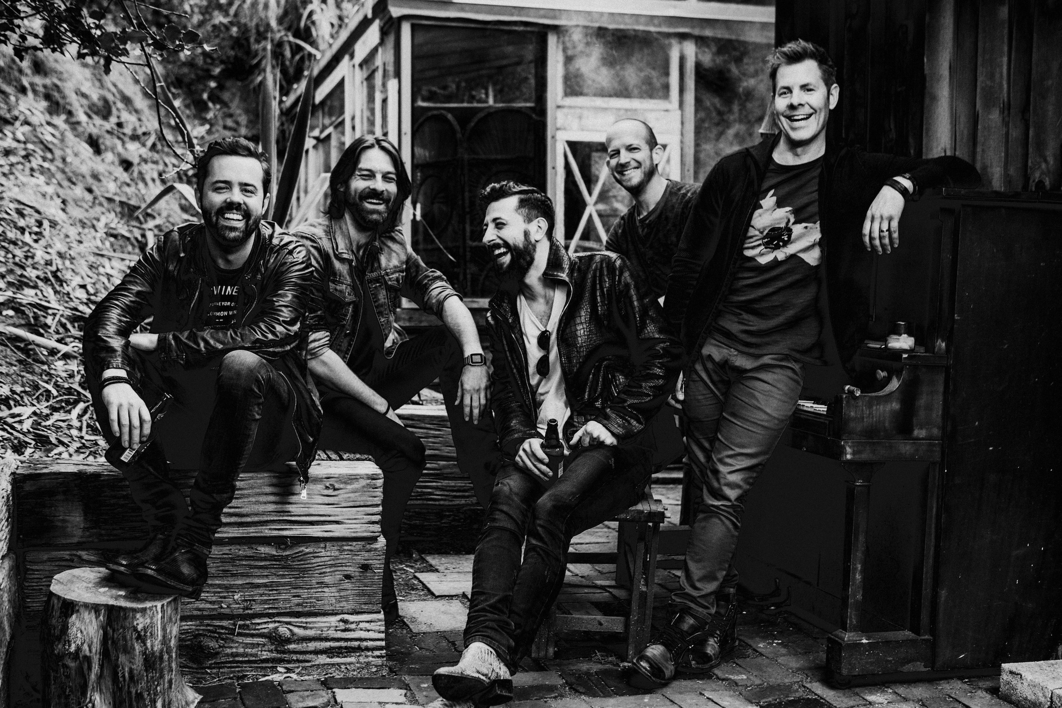
Photo #1: Old Dominion will perform a free concert during Fremont Street Experience’s 30th Annual Downtown Hoedown on Wed., Nov. 30 at 9:50 p.m. on the 3rd Street Stage.

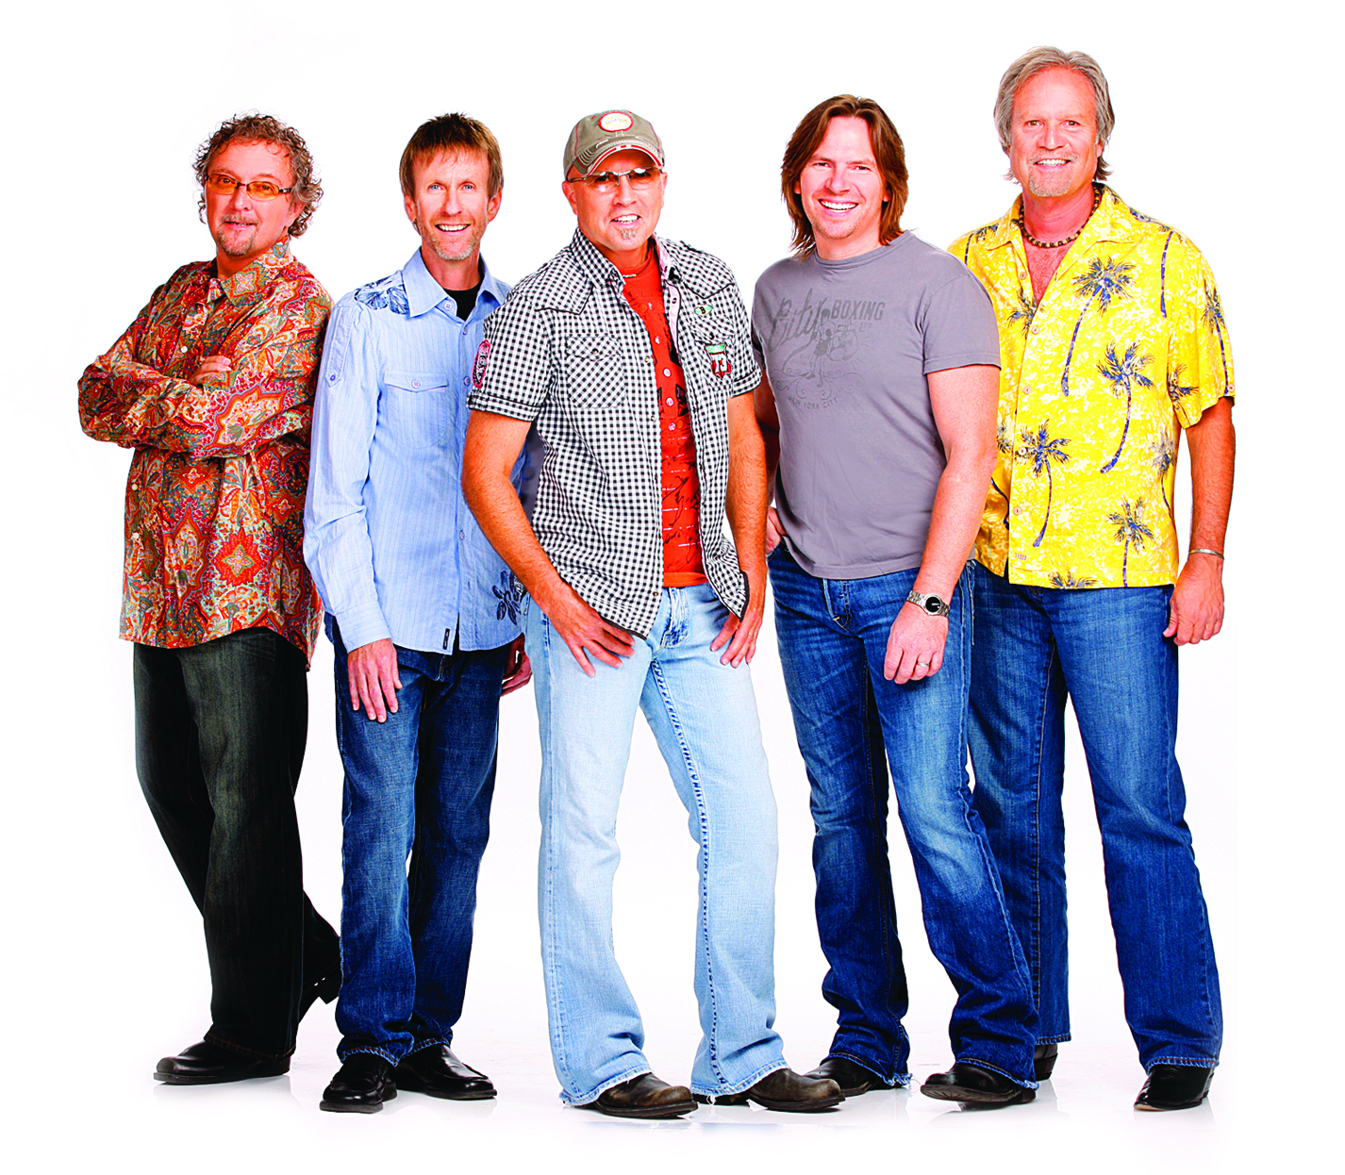
Photo #2: Sawyer Brown will perform a free concert during Fremont Street Experience’s 30th Annual Downtown Hoedown on Wed., Nov. 30 at 8:40 p.m. on the 1st Street Stage.

About Fremont Street Experience
Fremont Street Experience, a five-block entertainment district located in historic downtown Las Vegas features Viva Vision, North America’s largest video screen - 1,500 feet long, 90 feet wide and suspended 90 feet above the urban pedestrian mall. Viva Vision features nightly spectacular light and sounds shows with 12.5 million LED lights and a 550,000-watt sound system. Fremont Street Experience is a one-of-a-kind venue that includes free nightly concerts and entertainment on three stages. SlotZilla, the world’s most unique zipline attraction, features the 850-foot long Zipline and the 1,750-foot long Zoomline as people launch from a 12-story slot-machine themed takeoff platform to fly under the Viva Vision canopy. With direct pedestrian access to 10 casinos, more than 60 restaurants and specialty retail kiosks, Fremont Street Experience attracts more than 14 million annual visitors. Fremont Street Experience can be found online at www.vegasexperience.com.

“Like” Fremont Street Experience on Facebook: https://www.facebook.com/FSE89101
“Follow” Fremont Street Experience (@FSELV) on Twitter: https://twitter.com/FSELV

###

MEDIA CONTACT:

Rachel Diehl/Mallory Hanneke
Preferred Public Relations
702-254-5704

Rachel@preferredpublicrelations.com

Mallory@preferredpublicrelations.com

