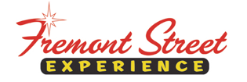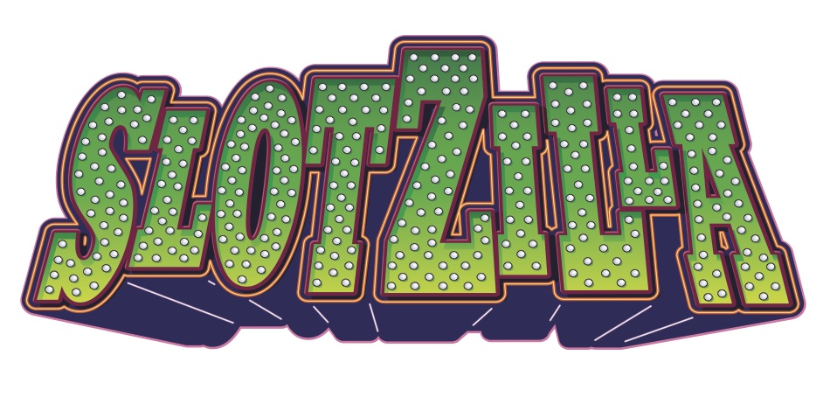

FOR IMMEDIATE RELEASE

Celebrate SlotZilla’s Month of the Millionth Flyer
at Fremont Street Experience

Month-long event celebrating SlotZilla’s milestone flight to feature daily flight giveaways
and a $1,000 prize for ten lucky winners

Click to Tweet (http://ctt.ec/305_t): Fly @SlotZillaLV during the Month of the Millionth Flyer this Sept. & you could win a free flight or $1,000 @FSELV vegasexperience.com

Las Vegas, NV – September 1, 2016 – SlotZilla™ will welcome its one millionth flyer this September, and Fremont Street Experience is celebrating all month long during the Month of the Millionth Flyer. Each day in September, several lucky guests, chosen at random at point of sale/ticket redemption, will receive a green bracelet indicating they won a pair of tickets for a free flight on SlotZilla. An online giveaway will also be conducted throughout the month through Fremont Street Experience’s Facebook page in which winners will be chosen at random and receive a pair of tickets for a free flight on SlotZilla. Additionally, on Wednesday, September 28 ten lucky flyers will receive a golden bracelet at point of sale/ticket redemption on-site, representing a $1,000 prize, equaling one million pennies between all winners (totaling $10,000). One of the ten golden bracelet recipients will also be recognized as the grand prize winner, which includes a one-year flight pass for SlotZilla along with $1,000. Las Vegas Mayor Carolyn G. Goodman will be onsite to celebrate this milestone. Learn more about the online and on-site giveaway and purchase your flights on SlotZilla at www.vegasexperience.com or by calling 1-844-ZIPVEGAS.

“Fremont Street Experience is excited to be celebrating this important milestone,” said Patrick Hughes, CEO and president of Fremont Street Experience, which owns and operates SlotZilla. “One million flyers is a huge accomplishment for any attraction, and we look forward to providing a thrill-seeking adventure under the neon sky to millions more throughout the years.”

SlotZilla flyers can also take advantage of a discount offered through a new partnership between Fremont Street Experience and Lyft. Individuals who sign up for Lyft and are new members can use the promo code FSE to receive a $50 credit toward future rides.

By The Numbers: One Million Flights on SlotZilla
The $17 Million attraction was built in 2012. Since then it has welcomed more than one million flyers equating to an average of 1.275 billion feet flown. That’s approximately:
- 22,176 flights up the Las Vegas Strip
- 455,032 flights across the United States
- More than 132 flights around the Earth
- 1 trip to the moon

Commitment to Charity
Additionally, Fremont Street Experience has given more than $200,000 to local nonprofit organizations during its SlotZilla Charity Challenge. Local nonprofits are chosen to partner with SlotZilla on a specific day and 100% of SlotZilla revenue from flights on the lower Zipline ($20) or upper Zoomline ($40) is donated to the organization. Past benefitting organizations include: Susan G. Komen Nevada, American Heart Association, Opportunity Village, The Animal Foundation and St. Jude’s Ranch for Children. The next charity challenge is scheduled for September 13, 2016 from 1-7 p.m. benefitting Three Square Food Bank.

Flight Info
SlotZilla combines innovative technology with a dynamic themed concept to transcend a traditional zipline ride, becoming a ground-breaking attraction for the amusement industry. The attraction features two thrill levels, a lower Zipline where flyers travel half the length of Fremont Street Experience in a traditional seated-harness position and an upper Zoomline where flyers are launched in a horizontal “superman” position 1,750 feet across the entire length of Fremont Street Experience. Both levels deliver an experience unique in the world – flying above thousands of people on Fremont Street Experience and under the four-block-long Viva Vision canopy, which is North America’s largest video screen.

SlotZilla is open Sundays through Thursdays from noon to midnight, and Fridays and Saturdays from noon to 2 a.m. Flights are $20 for the lower Zipline and $40 for the upper Zoomline. Flight times can be booked in advance at the SlotZilla ticketing, will call & check-in office located at 425 Fremont St., Ste. 160. Advance ticket purchases can also be made online at www.vegasexperience.com or by calling 1-844-ZIPVEGAS. Advance group sales for 20 or more tickets can be made by calling (702) 678-5780 or 1-844-SLOTZILLA.

About Fremont Street Experience
Fremont Street Experience, a five-block entertainment district located in historic downtown Las Vegas features Viva Vision, North America’s largest video screen - 1,500 feet long, 90 feet wide and suspended 90 feet above the urban pedestrian mall. Viva Vision features nightly spectacular light and sounds shows with 12.5 million LED lights and a 550,000-watt sound system. Fremont Street Experience is a one-of-a-kind venue that includes free nightly concerts and entertainment on three stages. SlotZilla, the world’s most unique zipline attraction, features the 850-foot Zipline and the 1,750-foot Zoomline as people launch from a 12-story slot-machine themed takeoff platform to fly under the Viva Vision canopy. With direct pedestrian access to 8 casinos, more than 60 restaurants and specialty retail kiosks, Fremont Street Experience attracts more than 17 million annual visitors. Fremont Street Experience can be found online at http://www.vegasexperience.com.

“Like” Fremont Street Experience on Facebook: https://www.facebook.com/FSE89101
“Follow” Fremont Street Experience (@FSELV) on Twitter: https://twitter.com/FSELV

MEDIA CONTACTS:
Rachel Diehl/Mallory Hanneke
Preferred Public Relations
702-254-5704
Rachel@preferredpublicrelations.com
Mallory@preferredpublicrealations.com

