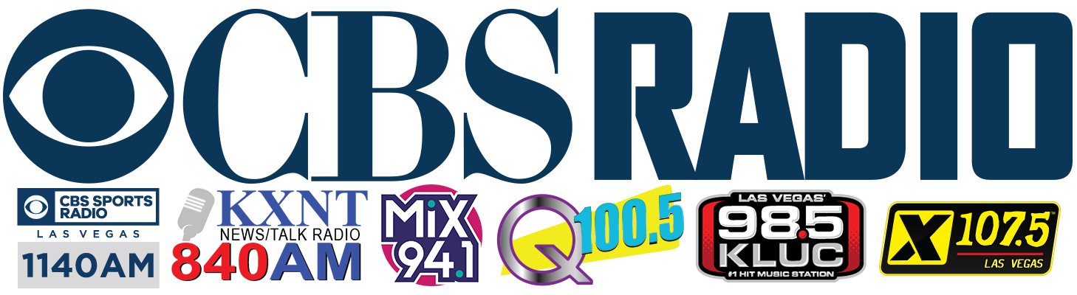

FOR IMMEDIATE RELEASE

Fremont Street Experience Presents
St. Jude’s Ranch for Children a Check for $15,787 from
SlotZilla Charity Challenge

Click to Tweet: (http://ctt.ec/Icadi) .@FSELV donates $15,787 to @StJudesRanch from @SlotzillaLV #CharityChallenge on Aug. 1! #LasVegas

Las Vegas, NV – Aug. 15, 2016 – Fremont Street Experience partnered with CBS RADIO stations: 98.5 KLUC, Mix 94.1, Q100.5, X107.5, and Newstalk 840AM KXNT, to host a SlotZilla Charity Challenge to benefit St. Jude’s Ranch for Children. On Monday, August 1 from noon – 6 p.m., 100% of SlotZilla revenue from flights on the lower Zipline and upper Zoomline went to St. Jude’s Ranch for Children, totaling $15,787.

“Fremont Street Experience is honored to raise money for St. Jude’s Ranch for Children as they do incredible work and have helped improve the lives of many children and families throughout our community,” said Hughes. “The support from the local CBS RADIO stations and the community was fantastic. It was great to see everyone flying down SlotZilla and having fun for a tremendous cause.”

Photo Caption 1: From left to right: Pamela Carlston, Director of Development of St. Jude’s Ranch for Children; Patrick Hughes, president and CEO of Fremont Street Experience. Fremont Street Experience presents a check for $15,787 to St. Jude’s Ranch for Children. The proceeds were raised from SlotZilla revenue on August 1, 2016 from noon to 6 p.m. Photo courtesy of Scott Roeben of Fremont Street Experience.

Photo Caption 2: CBS RADIO DJ’s from 98.5 KLUC, Mix 94.1, Q100.5, X107.5, and Newstalk 840AM KXNT and Patrick Hughes, President of Fremont Street Experience present a check for $15,787 to St. Jude’s Ranch for Children. The proceeds were raised from SlotZilla revenue on August 1, 2016 from noon to 6 p.m. CBS Radio DJ’s from all stations were on-site for live remotes during the event. Photo courtesy of CBS RADIO.

About St. Jude’s Ranch for Children
St. Jude’s Ranch for Children is a 501(c)3 non-profit organization that saves the lives of traumatized children. For 50 years, the charity has helped abused, neglected and homeless children and young adults, ages 0 to 25, by providing customized therapy and tools to break the cycle of abuse, as well as by keeping families and siblings together. The ultimate goal is to help these individuals find a forever family and achieve self-sufficiency. Approximately 60% of the children have been physically abused, 40% sexually abused, many have suffered both physical and sexual abuse, and 100% have been neglected. For more information visit www.stjudesranch.org and get social with us at facebook.com/stjudesranch, twitter.com/stjudesranch, linkedin.com/company/st-jude%27s-ranch.

About Fremont Street Experience
Fremont Street Experience, a five-block entertainment district located in historic downtown Las Vegas features Viva Vision, North America’s largest video screen - 1,500 feet long, 90 feet wide and suspended 90 feet above the urban pedestrian mall. Viva Vision features nightly spectacular light and sounds shows with 12.5 million LED lights and a 550,000-watt sound system. Fremont Street Experience is a one-of-a-kind venue that includes free nightly concerts and entertainment on three stages. SlotZilla, the world’s most unique zipline attraction, features the 850-foot Zipline and the 1,750-foot Zoomline as people launch from a 12-story slot-machine themed takeoff platform to fly under the Viva Vision canopy. With direct pedestrian access to 8 casinos, more than 60 restaurants and specialty retail kiosks, Fremont Street Experience attracts more than 17 million annual visitors. Fremont Street Experience can be found online at www.vegasexperience.com.

“Like” Fremont Street Experience on Facebook: https://www.facebook.com/FSE89101
“Follow” Fremont Street Experience (@FSELV) on Twitter: https://twitter.com/FSELV

About CBS RADIO
CBS RADIO is one of the largest major-market broadcast media operators in the United States and the undisputed leader in news and sports radio. Producing original audio and video content, live events and exclusive programming broadcast via on-air, online and mobile platforms, CBS RADIO reaches more than 72 million consumers nationwide each week. As a part of CBS Corporation, the division owns and operates 117 radio stations in 26 markets - including the top 10 as ranked by Nielsen Audio - as well as an extensive array of digital assets. CBS RADIO distributes its programming via AM, FM and HD Radio stations, Radio.com, Play.it and CBS Local Digital Media apps, making engaging with audiences easier than ever before. For more information on CBS RADIO, please visit www.cbsradio.com.

###

MEDIA CONTACT:
Rachel Diehl/Mallory Hanneke
Preferred Public Relations
702-254-5704 (Office)
702-290-5962 (Rachel Cell)
702-964-4222 (Mallory Cell)
rachel@preferredpublicrelations.com
mallory@preferredpublicrelations.com

