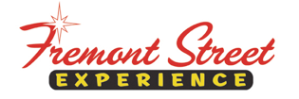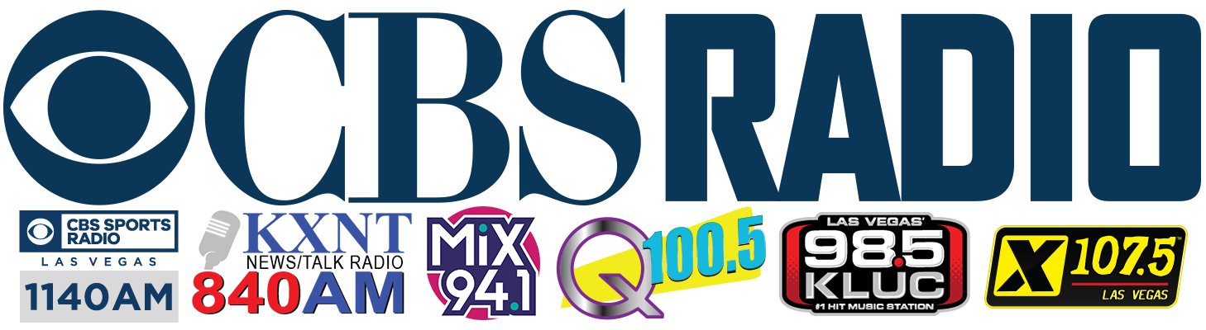

FOR IMMEDIATE RELEASE

Fremont Street Experience to Partner with
St. Jude’s Ranch for Children and CBS RADIO for SlotZilla Charity Challenge

100% of SlotZilla™ Revenue to Benefit
St. Jude’s Ranch for Children on August 1

Click to Tweet: (http://ctt.ec/Iw5fy) Fly on @SlotzillaLV @FSELV on 8/1 from noon-6p to support @StJudesRanch! 100% of revenue will benefit #StJudesRanch #CharityChallenge

Las Vegas, NV – July 21, 2016 – Fremont Street Experience will be partnering with CBS RADIO stations: 98.5 KLUC, Mix 94.1, Q100.5, X107.5, and Newstalk 840AM KXNT, to host a SlotZilla Charity Challenge, this time to benefit St. Jude’s Ranch for Children. Fremont Street Experience will be donating 100% of SlotZilla revenue to St. Jude’s Ranch on Monday, August 1 from noon to 6 p.m. On-air talent from each station will be on-site to support the event while doing live breaks from Fremont Street Experience. There will be a noon media event where children from St. Jude’s Ranch for Children and local celebrities will be on-site taking pictures and flying on SlotZilla. Flight times can be purchased at the SlotZilla box office or can be booked in advance online at www.vegasexperience.com.

“St. Jude’s Ranch for Children has deeply impacted Southern Nevada due to its dedication and commitment to taking care of traumatized children and families for the past 50 years,” said Thomas Bruny, Director of Marketing of Fremont Street Experience. “We hope that everyone will come out on Monday, August 1 to fly on SlotZilla and support a great cause in our community.”

SlotZilla ticketing, will call and check-in office is located next to the SlotZilla takeoff tower on Fremont Street between 4th Street and Las Vegas Boulevard. Parking is available at Fremont Street Experience parking garage with entrance off 4th Street just north of Carson.

Zipline – Flyers take off from the lower tier of the tower, 77 feet high and zip in a traditional seated-harness position on an 850-foot flight – half the length of Fremont Street Experience – to a mid-point landing platform located between 3rd Street and Casino Center.

Zoomline – Flyers launch from 114 feet high and zoom in a horizontal “superman” position going 35 mph 1,750 feet across the entire length of Fremont Street Experience, and land on a platform atop a newly built Main Street Stage.

Children under 13 in age must be accompanied by a flyer age 13 or over. Flyers must weigh between 50-300 lbs. for Zipline and 60-300 lbs. for Zoomline, with a maximum 6’8” height for lower Zipline but no height limit on upper Zoomline. Flyers cannot be under the influence of drugs and alcohol. Flyers should not ride if they have health concerns, neck/shoulder problems, are pregnant, have heart trouble, problems with balance, or seizure disorders.

About St. Jude’s Ranch for Children
St. Jude’s Ranch for Children is a 501(c)3 non-profit organization that saves the lives of traumatized children. For 50 years, the charity has helped abused, neglected and homeless children and young adults, ages 0 to 25, by providing customized therapy and tools to break the cycle of abuse, as well as by keeping families and siblings together. The ultimate goal is to help these individuals find a forever family and achieve self-sufficiency. Approximately 60% of the children have been physically abused, 40% sexually abused, many have suffered both physical and sexual abuse, and 100% have been neglected. For more information visit www.stjudesranch.org and get social with us at facebook.com/stjudesranch, twitter.com/stjudesranch, linkedin.com/company/st-jude%27s-ranch.

About Fremont Street Experience
Fremont Street Experience, a five-block entertainment district located in historic downtown Las Vegas features Viva Vision, North America’s largest video screen - 1,500 feet long, 90 feet wide and suspended 90 feet above the urban pedestrian mall. Viva Vision features nightly spectacular light and sounds shows with 12.5 million LED lights and a 550,000-watt sound system. Fremont Street Experience is a one-of-a-kind venue that includes free nightly concerts and entertainment on three stages. SlotZilla, the world’s most unique zipline attraction, features the 850-foot Zipline and the 1,750-foot Zoomline as people launch from a 12-story slot-machine themed takeoff platform to fly under the Viva Vision canopy. With direct pedestrian access to 8 casinos, more than 60 restaurants and specialty retail kiosks, Fremont Street Experience attracts more than 17 million annual visitors. Fremont Street Experience can be found online at www.vegasexperience.com.

“Like” Fremont Street Experience on Facebook: https://www.facebook.com/FSE89101
“Follow” Fremont Street Experience (@FSELV) on Twitter: https://twitter.com/FSELV

About CBS RADIO
CBS RADIO is one of the largest major-market broadcast media operators in the United States and the undisputed leader in news and sports radio. Producing original audio and video content, live events and exclusive programming broadcast via on-air, online and mobile platforms, CBS RADIO reaches more than 72 million consumers nationwide each week. As a part of CBS Corporation, the division owns and operates 117 radio stations in 26 markets - including the top 10 as ranked by Nielsen Audio - as well as an extensive array of digital assets. CBS RADIO distributes its programming via AM, FM and HD Radio stations, Radio.com, Play.it and CBS Local Digital Media apps, making engaging with audiences easier than ever before. For more information on CBS RADIO, please visit www.cbsradio.com.

###

FREMONT STREET EXPERIENCE MEDIA CONTACT:
Rachel Diehl/Mallory Hanneke
Preferred Public Relations
702-254-5704 (Office)
702-290-5962 (Rachel Cell)
702-964-4222 (Mallory Cell)
rachel@preferredpublicrelations.com
mallory@preferredpublicrelations.com

CBS RADIO CONTACT:
Katrina Llapitan
CBS RADIO Las Vegas
702-889-5928
Katrina.Llapitan@cbsradio.com

