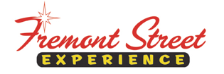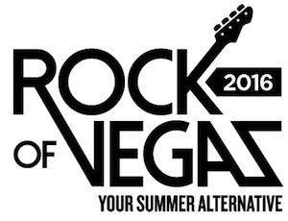

FOR IMMEDIATE RELEASE

Fremont Street Experience Rock of Vegas
Summer Concert Series Announces Full Lineup

Free concert series kicks off Memorial Day Weekend
and runs through Labor Day Weekend

Click to Tweet: http://ctt.ec/0rZ77 Celebrate the summer with the #RockofVegas free concert series at @FSELV kicking off on 5/28 with @joanjett & #TheBlackhearts

LAS VEGAS – May 11, 2016 – Fremont Street Experience Rock of Vegas concert series announces its full lineup for the summer that will transform the legendary downtown venue into summer’s hottest music destination. Celebrating its eighth anniversary, the free concerts have become one of the most popular summertime events in Las Vegas. The free concert series in Downtown Las Vegas will kick off Memorial Day Weekend with Joan Jett & The Blackhearts, and runs through Labor Day Weekend with a performance by Smash Mouth.

Rock of Vegas Summer Concert Series at Fremont Street Experience headliner concerts:

May 28 – Joan Jett & The Blackhearts – 3rd Street Stage
June 11 – 3 Doors Down – 3rd Street Stage
July 2 – Cherry Poppin’ Daddies – 1st Street Stage
July 23 – Robby Krieger of The Doors – 1st Street Stage
Aug. 6 – Vertical Horizon – 1st Street Stage
Aug. 20 – Melissa Etheridge – 1st Street Stage
Sept. 3 – Smash Mouth – 3rd Street Stage

(All concerts start at 9 p.m.)

“We are excited to announce the return of Fremont Street Experience’s free summer concert series, Rock of Vegas,” said Thomas Bruny, Director of Marketing of Fremont Street Experience. “We have an amazing lineup of nationally-recognized bands this year. There is something for everyone and you can’t beat the price – free – the best deal in Las Vegas this summer. In addition to the headliner concerts, we have nightly entertainment on three stages. We invite visitors and local residents to come to Downtown Las Vegas for a great summer of entertainment, plus the hotel-casinos offer amazing values on room rates, gambling, and food and drink specials.”

Joan Jett & The Blackhearts
Joan Jett is an originator, an innovator, and a visionary. As the leader of the hard-rocking Blackhearts, with whom she has become a Rock and Roll Hall of Fame inductee, she's had eight platinum and gold albums and nine Top 40 singles, including the classics “Bad Reputation,” “I Love Rock 'N' Roll,” “I Hate Myself For Loving You,” and “Crimson and Clover.” She sits at the head of her own independent label, Blackheart Records. Since co-founding the Runaways, the pioneering all-girl punk quintet, at age 15, Jett's determination and drive have kept her in the public eye. Her music has become a permanent force in mainstream culture. Jett & The Blackhearts released their latest record, Unvarnished, last year and continue touring the globe to throngs of adoring fans.

3 Doors Down
Formed in 1995, Grammy Award®-nominated multiplatinum Mississippi rock band 3 Doors Down consistently captivates audiences worldwide. The quintet’s many accolades include selling 16 million albums globally, receiving three Grammy nominations, and winning two American Music Awards. Their debut The Better Life, became certified six-times RIAA platinum in 2000 and was fueled by the success of juggernaut hit “Kryptonite.” This was followed by 2002’s sophomore album, Away from the Sun which went triple-platinum and saw similar success with “When I’m Gone” and “Here Without You.” 2005’s platinum Seventeen Days and 2008’s 3 Doors Down each earned #1 debuts on the Billboard Top 200, while Time of My Life landed at #3 in 2011. Ignited by the single “In The Dark,” 3 Doors Down unleashes their sixth full-length album, Us and the Night, in 2016.
Cherry Poppin’ Daddies
Cherry Poppin’ Daddies became a popular act during the swing revival of the late 1990s although the eight-piece band had formed one decade prior in Eugene, Oregon. The current lineup includes original members Steve Perry (who once performed under the mad scientist stage persona of "MC Large Drink") on lead vocals, bassist Dan Schmid and trumpeter Dana Heitman. The Cherry Poppin’ Daddies broke into the musical mainstream with their 1997 swing compilation Zoot Suit Riot: The Swingin’ Hits of the Cherry Poppin’ Daddies. Released at the onset of the late 1990s swing revival, the album went on to sell over two million copies in the United States while its eponymous single became a radio hit. The Daddies have been playing songs on tour from their newest release called The Boop-A-Doo. Cherry Poppin’ Daddies has always prided itself on its craft and musicianship that have allowed them to excel in whatever format they choose to tackle.

Robby Krieger of The Doors
Born in Los Angeles, California, Robby Krieger played in bands with friends where he eventually came into contact with drummer John Densmore. The two began jamming on blues together, later on meeting keyboardist Ray Manzarek and poet/singer Jim Morrison, resulting in the birth of The Doors. Quickly building a name for themselves in L.A. with their unpredictable live shows, The Doors were signed to Elektra Records, and issued their debut album, the Doors, in 1967. The album would become one of rock’s all-time classics, as it spawned the monster hit “Light My Fire,” a tune penned entirely by Krieger. Subsequent studio releases — 1967′s Strange Days, 1968′s Waiting for the Sun, and 1969′s the Soft Parade — all included several classic songs, and by the dawn of the ’70s, the band issued a pair of strong releases, 1970′s Morrison Hotel and 1971′s L.A. Woman. Krieger would go on to issue solo albums in addition to playing live dates, and guest appearances on albums by other artists. In the early 21st century, Krieger and Minaret resuscitated The Doors (with the Cult’s Ian Asbury taking Morrison’s position, and the Police’s Stewart Copeland initially taking Dunmore’s spot) for live shows and recordings. Robby is currently playing Doors songs with his Robby Krieger Band and special guest vocalist Waylon Krieger.

Vertical Horizon
Vertical Horizon was founded in the early 1990s, but it was seven years before lead singer Matt Scannell’s songs became the radio hits that brought the popular grass roots band to national attention. In 1999, they released their breakout album, Everything You Want, which went on to sell more than two million copies. The single “Everything You Want,” captured the #1 spot on Billboard’s Hot 100 and Adult Top 40 charts, and became Billboard’s Most Played Single of 2000. The band garnered further radio attention with “You’re a God” and “Best I Ever Had (Grey Sky Morning),” which in 2005 became a top 20 country hit for Gary Allan. Subsequent records followed included Go in 2003, Burning the Days in 2009 and their latest record, Echoes From The Underground, was released in 2013. Vertical Horizon tours extensively and in between tours Matt spends the majority of his time writing.

Melissa Etheridge
Melissa Etheridge stormed onto the American rock scene in 1988 with the release of her critically acclaimed self-titled debut album, which led to an appearance on the 1989 Grammy Awards show. For several years, her popularity grew around such memorable originals as “Bring Me Some Water,” “No Souvenirs” and “Ain't It Heavy,” for which she won a Grammy® in 1992. Etheridge hit her commercial and artistic stride with her fourth album, Yes I Am. The collection featured the massive hits, “I'm the Only One” and “Come to My Window,” a searing song of longing that brought Etheridge her second Grammy® Award for Best Female Rock Performance. In 1995, Etheridge issued her highest charting album, Your Little Secret, which was distinguished by the hit single, “I Want to Come Over.” Her astounding success that year led to Etheridge receiving the Songwriter of the Year honor at the ASCAP Pop Awards in 1996. Known for her confessional lyrics and raspy, smoky vocals, Etheridge has remained one of America’s favorite female singer-songwriters for more than two decades. In February 2007, Melissa Etheridge celebrated a career milestone with a victory in the “Best Song” category at the Academy® Awards for “I Need to Wake Up,” written for the Al Gore documentary on global warming, An Inconvenient Truth. Most recently, she released her latest album This Is M.E. in September 2014, which features singles Take My Number, A Little Bit of Me, and Monster.

Smash Mouth
Formed in late 1994, Smash Mouth began recording demos and showcasing in both San Jose and Hollywood, Calif. In June 1997, Smash Mouth signed to Interscope Records when label brass caught wind of an unknown (and unsigned) band being added to L.A. radio station KROQ's playlist after only one spin of their song “Walkin' on the Sun.” Smash Mouth's major-label debut Fush Yu Mang goes more than double platinum and sets the table for what most consider their masterpiece, the brilliant follow-up album Astrolounge. Boasting three top-ten hits (“All-Star,” “Then the Morning Comes,” and “Can't Get Enough Of You Baby”), sales for Astrolounge are nearly double than their debut album, approaching quadruple platinum status. Smash Mouth's third eponymous Interscope release features the ecstatic first single “Pacific Coast Party” and the smash hit “I'm a Believer” which was featured on the Shrek soundtrack. The band most recently released the album Magic and continue has focused on touring and entertaining troops in Japan, Guam, Guantanamo Bay, Afghanistan, and Iraq.

For complete information on the headliner concerts and nightly entertainment, visit www.vegasexperience.com.

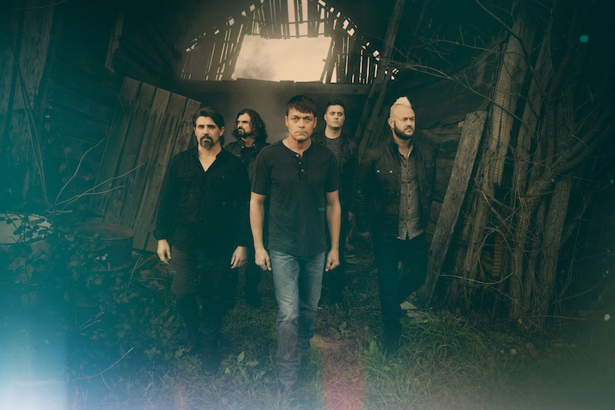
Photo #1: 3 Doors Down will perform a free concert during Fremont Street Experience’s Rock of Vegas summer concert series on Saturday, June 11 at 9 p.m. at the 3rd Street Stage.

About Fremont Street Experience
Fremont Street Experience, a five-block entertainment district located in historic downtown Las Vegas features Viva Vision, North America’s largest video screen - 1,500 feet long, 90 feet wide and suspended 90 feet above the urban pedestrian mall. Viva Vision features nightly spectacular light and sounds shows with 12.5 million LED lights and a 550,000-watt sound system. Fremont Street Experience is a one-of-a-kind venue that includes free nightly concerts and entertainment on three stages. SlotZilla, the world’s most unique zipline attraction, features the 850-foot Zipline and the 1,750-foot Zoomline as people launch from a 12-story slot-machine themed takeoff platform to fly under the Viva Vision canopy. With direct pedestrian access to 8 casinos, more than 60 restaurants and specialty retail kiosks, Fremont Street Experience attracts more than 17 million annual visitors. Fremont Street Experience can be found online at www.vegasexperience.com.

“Like” Fremont Street Experience on Facebook: https://www.facebook.com/FSE89101
“Follow” Fremont Street Experience (@FSELV) on Twitter: https://twitter.com/FSELV

###

MEDIA CONTACT:
Rachel Diehl
Preferred Public Relations
702-254-5704
Rachel@preferredpublicrelations.com

