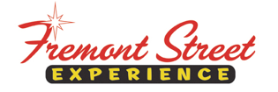

FOR IMMEDIATE RELEASE

Fremont Street Experience Presents Spread the Word Nevada a Check for $17,244 Raised at SlotZilla™

Spread the Word Nevada sets a new record for the most
amount of money raised at a weekday SlotZilla Charity Challenge

Las Vegas, NV – March 15, 2016 – Fremont Street Experience hosted a SlotZilla Charity Challenge to benefit Spread the Word Nevada. On Thursday, Feb. 25 from 1 p.m. –
7 p.m., 100% of SlotZilla revenue from flights on the lower Zipline or upper Zoomline went to Spread the Word Nevada. Fremont Street Experience Director of Marketing, Thomas Bruny, presented the organization a check for $17,244 on Monday, March 7.

“We are thrilled that so many people came down and supported Spread the Word Nevada by flying on Slotzilla,” said Bruny. “We had an extremely successful day and ended up setting the largest weekday SlotZilla Charity Challenge record with $17,244. All of that money will go to this terrific organization that is dedicated to advancing early childhood literacy by placing books into the hands and homes of children within Southern Nevada’s at-risk, low income communities. They buy books at a dollar each, so that means 17,244 new books.”

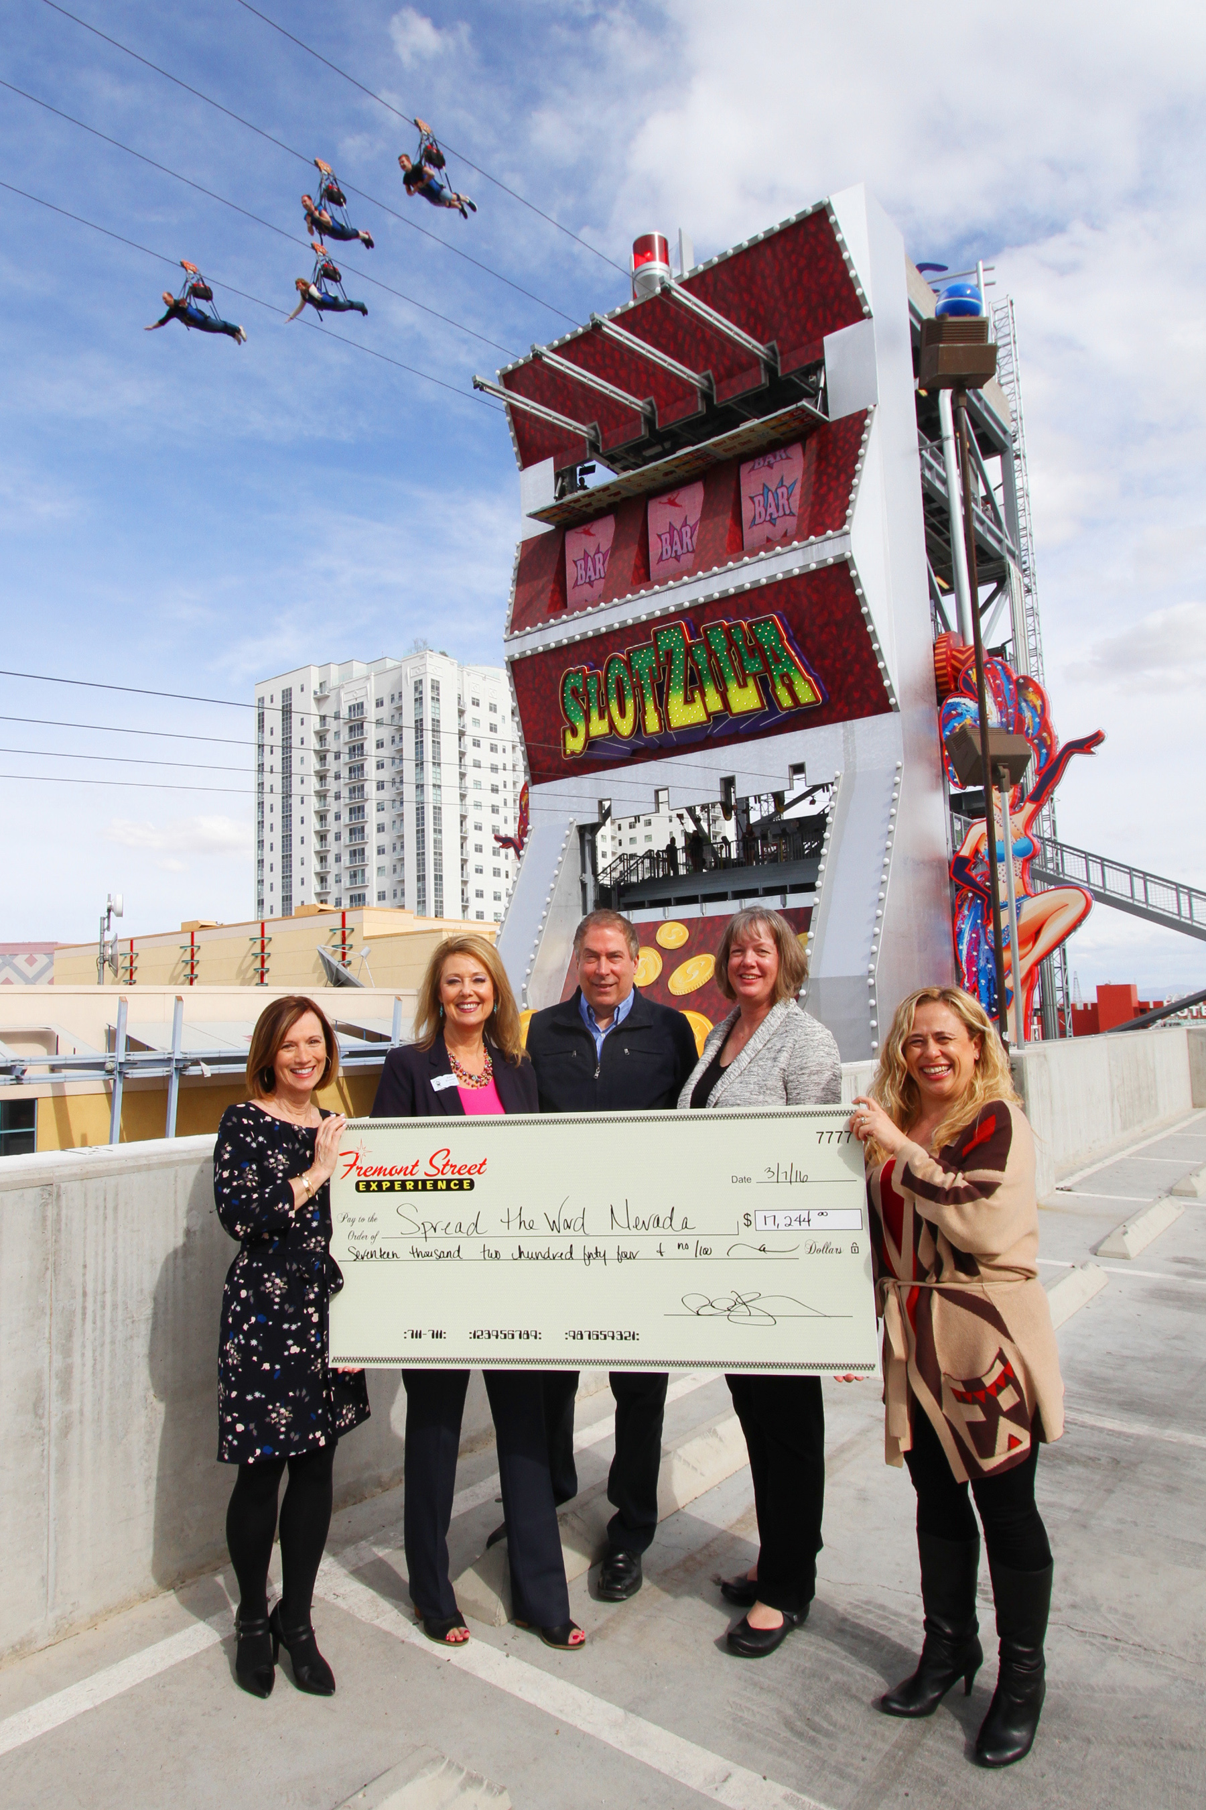
Photo Caption: From left to right: Pamela Lang, Spread the Word Nevada Board Member; Kris Hanson, Spread the Word Nevada Board Member; Thomas Bruny, Director of Marketing of Fremont Street Experience; Kris Hipwell, Spread the Word Nevada Board Member; Vicki Soares, Director of Marketing of Spread the Word Nevada. Fremont Street Experience presents a check for $17,244 to Spread the Word Nevada. The proceeds were raised from SlotZilla revenue on Feb. 25, 2016. Photo courtesy of Scott Roeben of Fremont Street Experience.

About SlotZilla™
Zip & Zoom – Vegas Style on the world’s most unique zipline – SlotZilla™ at Fremont Street Experience located in Downtown Las Vegas. SlotZilla combines innovative technology with a dynamic themed concept to transcend a traditional zipline ride, becoming a ground-breaking attraction for the amusement industry. The attraction features two thrill levels, a lower Zipline where flyers travel half the length of Fremont Street Experience in a traditional seated-harness position and an upper Zoomline where flyers are launched in a horizontal “superman” position 1,750 feet across the entire length of Fremont Street Experience. Both levels deliver an experience unique in the world – flying above thousands of people on Fremont Street Experience and under the four-block-long Viva Vision canopy, which is North America’s largest video screen.

SlotZilla is open Sundays through Thursdays from 1 p.m. to 1 a.m., and Fridays and Saturdays from 1 p.m. to 2 a.m. Flights are $20 before 6 p.m. and $25 after 6 p.m. for the lower Zipline and $40 before 6 p.m. and $45 after 6 p.m. for the upper Zoomline. Flight times can be booked in advance at the SlotZilla ticketing, will call & check-in office located at 425 Fremont St., Ste. 160. Advance ticket purchases can also be made online at www.vegasexperience.com or by calling 1-844-ZIPVEGAS. Advance group sales for 10 or more tickets can be made by calling (702) 678-5780 or 1-844-SLOTZILLA.

Visit online at www.vegasexperience.com, Facebook: facebook.com/SlotZillaLasVegas, Twitter: @SlotZillaLV, or Yelp: http://www.yelp.com/biz/slotzilla-las-vegas

###

MEDIA CONTACTS:
Lauren Silverstein
Preferred Public Relations
702-254-5704
Lauren@preferredpublicrelations.com

