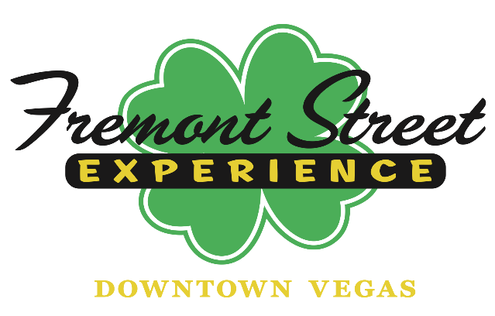
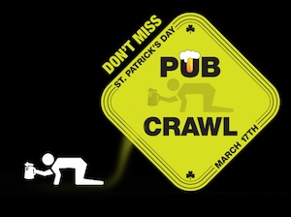

FOR IMMEDIATE RELEASE

Celebrate St. Patrick’s Day at Fremont Street Experience
with a ShamROCK Celebration

Paint Downtown Las Vegas Irish Green with five-days of free entertainment,
and the 8th Annual St. Patrick’s Day Pub Crawl

LAS VEGAS – March 16, 2016 – Fremont Street Experience invites the public to enjoy a ShamROCK celebration and paint downtown Las Vegas Irish Green this St. Patrick’s Day with five days of entertainment, plenty of drink specials and the 8th Annual St. Patrick’s Day Pub Crawl. Entertainment will feature traditional and modern Irish bands including: The Johnny McCuaig Band; The Angry Brians; Finnegan’s Wake; Celtic Rockers; LA Vation (U2 tribute band); Tempest and The Bogtrotter’s Union.

St. Patrick’s Day (Thursday, March 17) Entertainment Schedule:
1st Street Stage
- 12 p.m. – 3 p.m. – Celtic Rockers
- 3 p.m. – 7 p.m. – Tempest
- 7 p.m. – 10 p.m. – Yellow Brick Road
- 10 p.m. – 1 a.m. – The Johnny McCuaig Band
3rd Street Stage
- 1 p.m. – 5 p.m. – The Bogtrotter’s Union
- 5 p.m. – 8 p.m. – Hardwood Hotties
- 8 p.m. – 11 p.m. – The Angry Brians
- 11 p.m. – 2 a.m. – Zowie Bowie
Main Street Stage
- 12 p.m. – 4 p.m. – Finnegan’s Wake
- 4 p.m. – 7 p.m. – Celtic Rockers
- 7 p.m. – 10 p.m. – LA Vation (U2 Tribute Band)
- 10 p.m. – 2 a.m. – Luck of the Spandex (Nation)

St. Patrick’s Day Pub Crawl – Thursday, March 17 from 2 p.m. – 12 a.m.
On Thursday, March 17, paint downtown Las Vegas green during the 8th Annual St. Patrick’s Day Pub Crawl. This free event will feature 12 hours of Shamrockin’ entertainment and golden drink specials from participating downtown properties. Guests must be 21+ years of age. ID will be required upon arrival.

Parking is available at the Fremont Street Experience garage at (located on the NE corner of Carson & 4th Street). Guests can check in to pick up wristbands at the base of SlotZilla located near the Fremont Street Experience garage elevators (Mall level – 1st Floor) between 2-8 p.m. The first 400 people to check in at the event will receive a free Pub Crawl t-shirt.

St. Patrick’s Day Pub Crawl Specials
Pub Crawlers can receive special offers from several downtown locations including: Binion’s Gambling Hall and Hotel; The D Las Vegas; Four Queens Hotel & Casino; Fremont Hotel & Casino; Golden Gate Hotel & Casino; and Golden Nugget Las Vegas.

Binion’s –
At Benny’s – 14oz draft domestic green beer and a shot of Jameson Black Irish Whiskey, $6
At outdoor bars – shot of Jameson Black Irish Whiskey, $5

The D –
Jameson Boiler Makers, $9
Dirty Girl Scout Cookies, $5
Free t-shirt with purchase of Green Beer pitcher (outside bar only)

Four Queens –
At Chicago Brew Pub – shot of Goldshlager with crème de menthe, $4
At outdoor bar – shot of Jameson Black Irish Whiskey, $5

Fremont’s –
At Filament Bar – Leprechaun Lemonade (Sweetened Irish Whiskey with Lemon and Mint), $4
Guinness Draught, $4; add a Shot of Jameson, $7

Golden Gate –
Jameson Boiler Makers, $9
Dirty Girl Scout Cookies, $5

Golden Nugget (Gold Diggers only, opens 8 p.m., $10 cover after 11 p.m.)
Guinness, $5
Heineken, $5
Jameson, $6
Scooby Snack Shots (midori, Malibu, crem de banana, pineapple, whipped cream), $6

St. Patrick’s Day Weekend Entertainment Schedule
Celebrate St. Patrick’s Day all weekend long as Fremont Street Experience feature free shamrockin’ entertainment from traditional and modern Irish bands beginning Wednesday, March 16 and lasting through Sunday, March 20. The additional entertainment line-up is:

Wednesday, March 16
1st Street Stage
- 8 p.m. – 11 p.m. – The Johnny McCuaig Band
3rd Street Stage
- 5 p.m. – 7 p.m. – Dancing DJ
- 7 p.m. – 10 p.m. – Hardwood Hotties
- 10 p.m. – 1 a.m. – The Angry Brians
Main Street Stage
- 6 p.m. – 10 p.m. – Dancing DJ
- 10 p.m. – 1 a.m. – Alter Ego

Friday, March 18
1st Street Stage
- 6 p.m. – 9 p.m. – Tempest
- 9 p.m. – 12 a.m. – The Johnny McCuaig Band
3rd Street Stage
- 5 p.m. – 8 p.m. – Dancing DJ
- 8 p.m. – 11 p.m. – Hardwood Hotties
- 11 p.m. – 2 a.m. – Angry Brians
Main Street Stage
- 4 p.m. – 7 p.m. – Dancing DJ
- 7 p.m. – 10 p.m. – LA Vation (U2 Tribute Band)
- 10 p.m. – 2 a.m. – Spandex Nation

Saturday, March 19
1st Street Stage
- 4 p.m. – 7 p.m. – Dancing DJ
- 6 p.m. – 9 p.m. – Tempest
- 9 p.m. – 12 a.m. – The Johnny McCuaig Band
3rd Street Stage
- 12 p.m. – 5 p.m. – Dancing DJ
- 5 p.m. – 8 p.m. – Hardwood Hotties
- 8 p.m. – 11 p.m. – The Angry Brians
- 11 p.m. – 2 a.m. – ’80s Station
Main Street Stage
- 12 p.m. – 4 p.m. – Dancing DJ
- 4 p.m. – 7 p.m. – Celtic Rockers
- 7 p.m. – 10 p.m. – Police Experience (Police Tribute Band)
- 10 p.m. – 2 a.m. – Spandex Nation

Sunday, March 20
1st Street Stage
- 5 p.m. – 8 p.m. – Dancing DJ
- 8 p.m. – 11 p.m. – Tyler James - Elvis
3rd Street Stage
- 5 p.m. – 7 p.m. – Dancing DJ
- 7 p.m. – 10 p.m. – Hardwood Hotties
- 10 p.m. – 1 a.m. – The Angry Brian’s
Main Street Stage
- 4 p.m. – 7 p.m. – Police Experience (Police Tribute Band)
- 7 p.m. – 10 p.m. – Dancing DJ
- 10 p.m. – 1 a.m. – Spandex Nation

*All offers and entertainment are subject to availability and change without notice.

About The Johnny McCuaig Band
The Johnny McCuaig Band is a band with bagpipes but their rock and roll sound sets them apart from other Irish bands – a Celtic band they are not. This five piece rock band is led by Johnny McCuaig on guitar, bagpipes and vocals, Kevin Kyle on bass, Martin Zinger on drums and James Picton and Allan Morrison on guitar. They have shared the stage with such acts as Foreigner, Buckcherry and The Trews throughout the years. Their unique sound seamlessly blends almost every style of popular music together – the blues mixed with a 70s groove or a chugging rock guitar interlaced with bagpipes. Johnny McCuaig brings bagpipes to a whole new level by playing them as a lead instrument all while wearing a kilt.
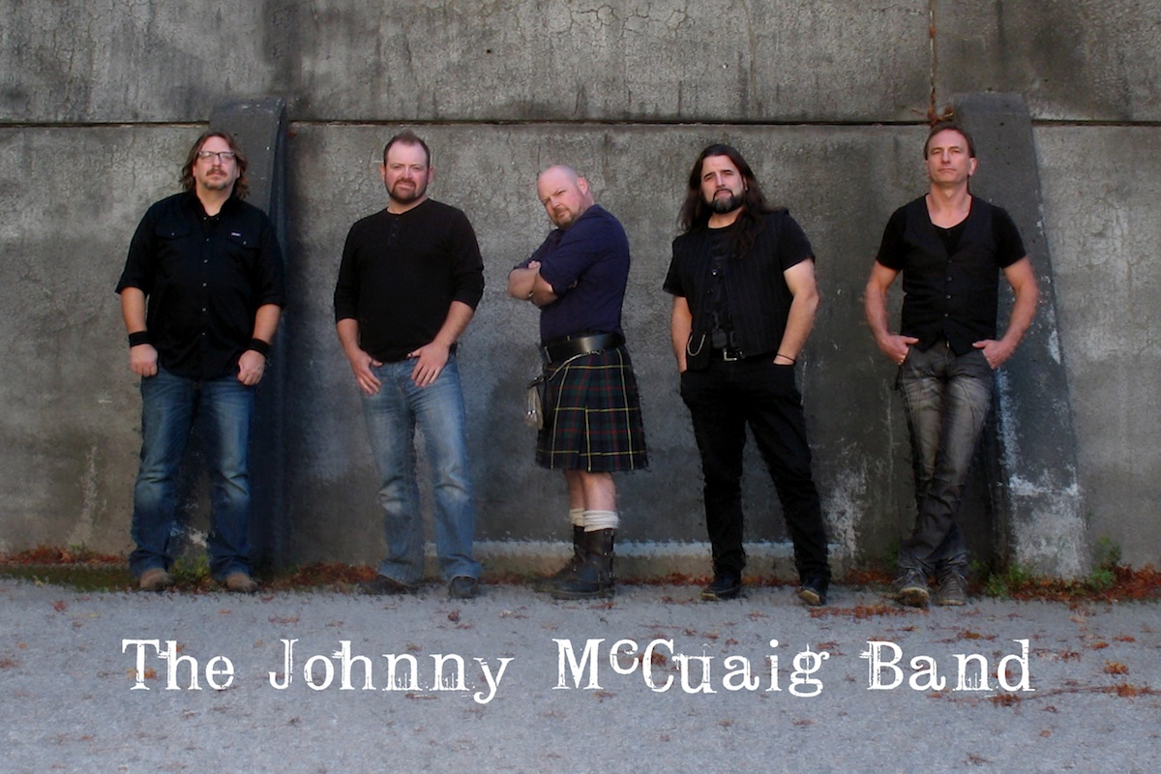
Photo: The Johnny McCuaig Band will perform nightly at Fremont Street Experience’s St. Patrick’s ShamROCK celebration on the 1st Street Stage March 16 – March 19.

About Fremont Street Experience
Fremont Street Experience, a five-block entertainment district located in historic downtown Las Vegas features Viva Vision, America’s largest video screen - 1,500 feet long, 90 feet wide and suspended 90 feet above the urban pedestrian mall. Viva Vision features nightly spectacular light and sounds shows with 12.5 million LED lights and a 550,000-watt sound system. Fremont Street Experience is a one-of-a-kind venue that includes free nightly concerts and entertainment on three stages. SlotZilla, the world’s most unique zipline attraction, includes the 850-foot Zipline and the 1,750-foot Zoomline as people launch from a 12-story slot-machine themed takeoff platform to fly under the Viva Vision canopy. With direct pedestrian access to 8 casinos, more than 60 restaurants and specialty retail kiosks, Fremont Street Experience attracts more than 17 million annual visitors. Fremont Street Experience can be found online at www.vegasexperience.com.

“Like” Fremont Street Experience on Facebook: https://www.facebook.com/FSE89101
“Follow” Fremont Street Experience (@FSELV) on Twitter: https://twitter.com/FSELV

###

MEDIA CONTACT:
Lauren Silverstein
Preferred Public Relations
702-254-5704
Lauren@preferredpublicrelations

