FOR IMMEDIATE RELEASE

Patrick Hughes Named New President & CEO
of Fremont Street Experience

Casino executive to take on Downtown Las Vegas
leadership role at the end of the month

LAS VEGAS, NV – Feb. 11, 2016 – The Fremont Street Experience Board has named Cannery Casino & Hotel Vice President and General Manager, Patrick Hughes, as the new President and CEO of Fremont Street Experience. Hughes, who will begin work at FSE on Feb. 29, succeeds former President Jeff Victor, who departed the company last fall.

A native of Ireland, Hughes has had an extensive career in gaming, hospitality and entertainment over the last two decades. He moved to Las Vegas at the age of 25 and has worked for a number of hotel-casino resorts including Boulder Station Casino & Hotel, New York-New York Casino and The Resort At Summerlin. Hughes was on the opening team of The Resort at Summerlin in 1999 and held many positions at that property from Gaming Manager to General Manager of Rampart Casino. He has been at the Cannery Casino & Hotel in North Las Vegas for the past four years as Vice President and General Manager of the property where he oversaw all management of the property, including gaming, hotel operations and entertainment.

“The Fremont Street Experience Board is thrilled to have Patrick Hughes take the leadership position of Downtown Las Vegas’ premier destination,” said Mark Brandenburg, FSE Board Interim Chairman. “In the 20 years since its inception, Fremont Street Experience has changed the face of Downtown Las Vegas. We believe Patrick is the person who can lead Fremont Street Experience into its next decade of growth and innovation.”

“It is with bittersweet emotions that I leave the Cannery family to whom I am truly thankful for their support,” Hughes said. “I am honored and excited to join Fremont Street Experience and I look forward to working with this incredibly talented team to making this a global destination that will be the centerpiece of this City.”

Fremont Street Experience, LLC is a private company that manages the five-block entertainment destination on Fremont Street, including America’s largest video screen, three stages and SlotZilla, the world’s most unique zipline. The FSE Board of Managers is made up of representatives from its eight member hotel-casinos – Binion’s, California, the D, Four Queens, Fremont, Golden Gate, Golden Nugget and Main Street Station.

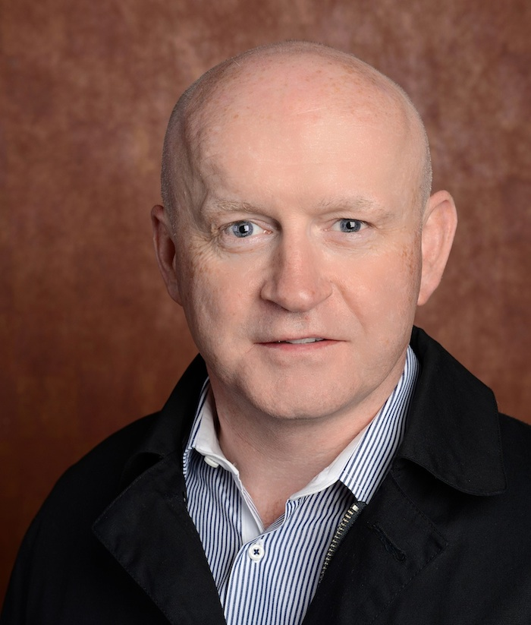
Photo Caption: Patrick Hughes named new President & CEO of Fremont Street Experience.

About Fremont Street Experience
Fremont Street Experience, a five-block entertainment district located in historic downtown Las Vegas features Viva Vision, America’s largest video screen - 1,500 feet long, 90 feet wide and suspended 90 feet above the urban pedestrian mall. Viva Vision features nightly spectacular light and sounds shows with 12.5 million LED lights and a 550,000-watt sound system. Fremont Street Experience is a one-of-a-kind venue that includes free nightly concerts and entertainment on three stages. SlotZilla, the world’s most unique zipline attraction, includes the 850-foot Zipline and the 1,750-foot Zoomline as people launch from a 12-story slot-machine themed takeoff platform to fly under the Viva Vision canopy. With direct pedestrian access to 8 casinos, more than 60 restaurants and specialty retail kiosks, Fremont Street Experience attracts more than 17 million annual visitors. Fremont Street Experience can be found online at www.vegasexperience.com.

“Like” Fremont Street Experience on Facebook: https://www.facebook.com/FSE89101
“Follow” Fremont Street Experience (@FSELV) on Twitter: https://twitter.com/FSELV

###
MEDIA CONTACT:
Lauren Silverstein
Preferred Public Relations
702-254-5704
Lauren@preferredpublicrelations

