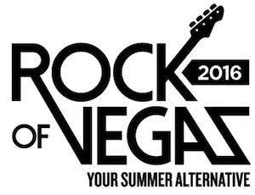

FOR IMMEDIATE RELEASE

Joan Jett & The Blackhearts to Kick-Off Rock of Vegas
Summer Concert Series at Fremont Street Experience

Celebrate Memorial Day Weekend in Downtown Las Vegas
with a Free Concert on Saturday, May 28

Click to Tweet: http://ctt.ec/F9nC2 Celebrate #MemorialDayWeekend with a #FreeConcert from @joanjett & #TheBlackhearts on the 3rd Street Stage @FSELV 5/28 at 9 pm. #RockofVegas

LAS VEGAS, NV – Jan. 11, 2016 – Fremont Street Experience’s Rock of Vegas concert series will kick-off the summer this Memorial Day weekend with a free concert featuring Joan Jett & The Blackhearts, Saturday, May 28 at 9 p.m. on the 3rd Street Stage. Celebrating its eighth season, the free concerts have become one of the most popular summertime events in Las Vegas. This year’s lineup will turn the legendary downtown Las Vegas entertainment venue into summer’s alternative destination through Labor Day weekend with a free concert series that showcases a stellar lineup of bands that have taken music to the edge.

“We are ecstatic to have Joan Jett & The Blackhearts kick off Fremont Street Experience’s eighth summer concert series this year,” said Thomas Bruny, Director of Marketing of Fremont Street Experience. “Downtown Las Vegas is such an energetic place to see a live concert and offers the best values in the city. All the concerts and stage shows are free, plus the downtown hotel-casinos offer great deals on room rates, gambling and many food and drink specials.”

Joan Jett
Joan Jett is an originator, an innovator, and a visionary. As the leader of the hard-rocking Blackhearts, with whom she has become a Rock and Roll Hall of Fame inductee, she's had eight platinum and gold albums and nine Top 40 singles, including the classics “Bad Reputation,” “I Love Rock 'N' Roll,” “I Hate Myself For Loving You,” and “Crimson and Clover.” She sits at the head of her own independent label, Blackheart Records. Since co-founding the Runaways, the pioneering all-girl punk quintet, at age 15, Jett's determination and drive have kept her in the public eye. Her music has become a permanent force in mainstream culture. A version of “I Hate Myself for Loving You” was performed by Carrie Underwood as the intro to NBC's Sunday Night Football, and her music is heard in countless films and TV shows. Jett and the Blackhearts released their latest record, Unvarnished, last year and continue touring the globe to throngs of adoring fans.

For complete information on the headliner concerts and nightly entertainment, visit www.vegasexperience.com.

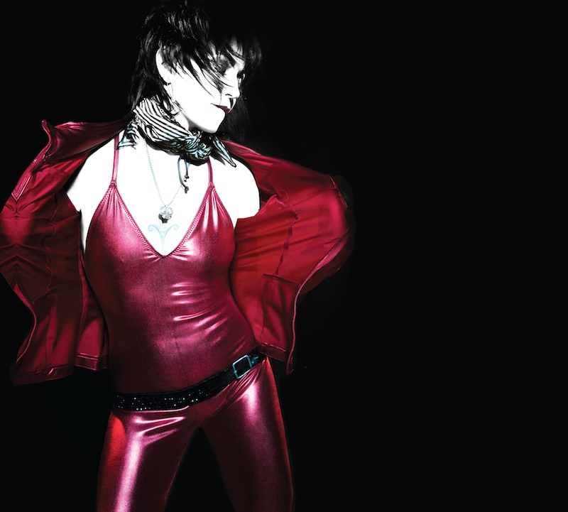
Photo #1: Joan Jett & The Blackhearts will kick off the Rock of Vegas summer concert series at Fremont Street Experience on Saturday, May 28. Photo by Roger Erickson.

About Fremont Street Experience
Fremont Street Experience, a five-block entertainment district located in historic downtown Las Vegas features Viva Vision, North America’s largest video screen - 1,500 feet long, 90 feet wide and suspended 90 feet above the urban pedestrian mall. Viva Vision features nightly spectacular light and sounds shows with 12.5 million LED lights and a 550,000-watt sound system. Fremont Street Experience is a one-of-a-kind venue that includes free nightly concerts and entertainment on three stages. SlotZilla, the world’s most unique zipline attraction, features the 850-foot Zipline and the 1,750-foot Zoomline as people launch from a 12-story slot-machine themed takeoff platform to fly under the Viva Vision canopy. With direct pedestrian access to 8 casinos, more than 60 restaurants and specialty retail kiosks, Fremont Street Experience attracts more than 17 million annual visitors. Fremont Street Experience can be found online at www.vegasexperience.com.

“Like” Fremont Street Experience on Facebook: https://www.facebook.com/FSE89101
“Follow” Fremont Street Experience (@FSELV) on Twitter: https://twitter.com/FSELV

###
MEDIA CONTACT:
Lauren Silverstein/James Woodrow
Preferred Public Relations
702-254-5704
Lauren@preferredpublicrelations
James@preferredpublicrelations.com

