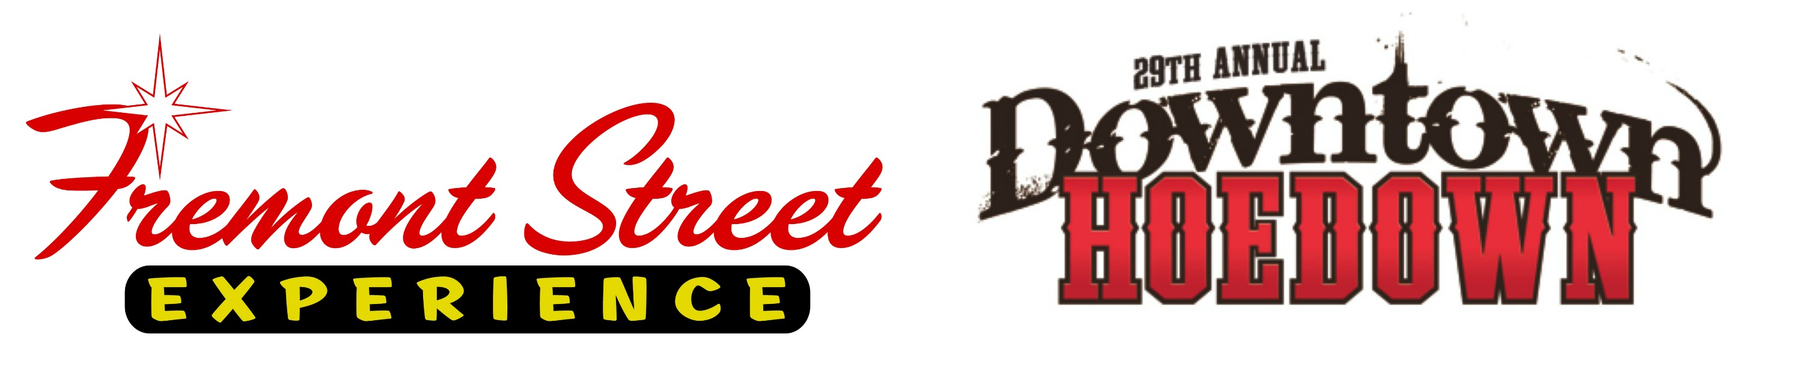

FOR IMMEDIATE RELEASE

Say Howdy to the Holidays this December at
Fremont Street Experience

Celebrate the return of National Finals Rodeo to Las Vegas with
the 29th Annual Downtown Hoedown, 12 Days of Country and 4th Annual Downtown Throwdown

Click to Tweet: http://ctt.ec/13ugk .@FSELV's 12 Days of Country kicks off Dec. 2 at the #DowntownHoedown and runs through Dec. 13. For more info, visit: vegasexperience.com

Las Vegas, NV – Nov. 25, 2015 – Fremont Street Experience invites all cowboys, cowgirls and country music fans to say howdy to the holidays in downtown Las Vegas to celebrate the return of National Finals Rodeo. Throughout the month of December, Fremont Street Experience will feature free performances from top country music stars as well as a rowdy line-up from top local artists during the 29th Annual Downtown Hoedown on Dec. 2 and 12 Days of Country taking place Dec. 2-13. Additionally, get your cowboy feast on during the 4th Annual Downtown Throwdown barbecue championships taking place Dec. 11-12.

“This lineup for the 29th Annual Downtown Hoedown and 12 Days of Country is sure to excite country music fans as we are showcasing free performances from nationally-recognized top artists as well as locally known and loved acts,” said Thomas Bruny, Director of Marketing at Fremont Street Experience. “Additionally, we are hosting the Downtown Throwdown Barbecue Championships for the fourth year and we invite the public to taste the delicious results for themselves.”

29th Annual Downtown Hoedown
The 29th Annual Downtown Hoedown kicks off the 12 Days of Country on Fremont Street Experience. To continue a long tradition of smash-hit headliners, this year’s lineup will feature performances from country superstars Montgomery Gentry, Tracy Lawrence, Chris Janson, Chase Bryant, JT Hodges and Jackson Michelson on Fremont Street Experience’s three stages, with all performances free to the public.

29th Annual Downtown Hoedown performance schedule of the headliners:

4:30 p.m. – 5:30 p.m Tracy Lawrence on 1st Street Stage
5:40 p.m. – 6:25 p.m Jackson Michelson on Main Street Stage
6:35 p.m. – 7:20 p.m Chase Bryant on 3rd Street Stage
7:30 p.m. – 8:30 p.m JT Hodges on Main Street Stage
8:40 p.m. – 9:40 p.m Chris Janson on 1st Street Stage
9:50 p.m. – 11:20 p.m. Montgomery Gentry on 3rd Street Stage

12 Days of Country

12 Days of Country returns to Fremont Street Experience, kicking off at the 29th Annual Downtown Hoedown on Dec. 2 and lasting through Dec. 13. This year 12 Days of Country, which celebrates the return of National Finals Rodeo, will feature free nightly entertainment with a rowdy line-up from top local favorites including Jimmy Ray & Black Train, Red, White and Blue Tour; Siana King; Tony Marques; Cash Presley; Crossroad South; Route 66 and VooDoo Cowboys, as well as the nightly Dancing DJ spinning the best country tunes.

For the full 12 Days of Country schedule, please visit www.vegasexperience.com.

4th Annual Downtown Throwdown
Fremont Street Experience in conjunction with the Nevada Barbecue Association will host the 4th Annual Downtown Throwdown Barbecue Championships in downtown Las Vegas on Dec. 11 and 12. The Kansas City Barbecue Society sanctioned competition will feature a Chili Cook-Off on Friday, Dec. 11 at 4 p.m. and Barbecue Cook-Off on Saturday, Dec. 12 beginning at noon. The public is invited to enjoy delicious samples of chili, ribs, chicken, brisket and pork during the two-day event as guests will be able to purchase the food from some of the best cowboy cooks around.

About Fremont Street Experience
Fremont Street Experience, a five-block entertainment district located in historic downtown Las Vegas features Viva Vision, North America’s largest video screen - 1,500 feet long, 90 feet wide and suspended 90 feet above the urban pedestrian mall. Viva Vision features nightly spectacular light and sounds shows with 12.5 million LED lights and a 550,000-watt sound system. Fremont Street Experience is a one-of-a-kind venue that includes free nightly concerts and entertainment on three stages. SlotZilla, the world’s most unique zipline attraction, features the 850-foot long Zipline and the 1,750-foot long Zoomline as people launch from a 12-story slot-machine themed takeoff platform to fly under the Viva Vision canopy. With direct pedestrian access to 10 casinos, more than 60 restaurants and specialty retail kiosks, Fremont Street Experience attracts more than 14 million annual visitors. Fremont Street Experience can be found online at www.vegasexperience.com.

“Like” Fremont Street Experience on Facebook: https://www.facebook.com/FSE89101
“Follow” Fremont Street Experience (@FSELV) on Twitter: https://twitter.com/FSELV

###

MEDIA CONTACTS:
Lauren Silverstein
Preferred Public Relations
702-254-5704
Lauren@preferredpublicrelations.com

