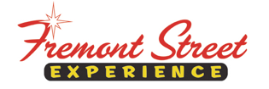

FOR IMMEDIATE RELEASE

Fremont Street Experience Presents American Heart Association a Check for $19,960 Raised at SlotZilla™

The American Heart Association sets a new record for the most
amount of money raised at a SlotZilla Charity Challenge

Las Vegas, NV – November 23, 2015 – Fremont Street Experience hosted a SlotZilla Charity Challenge to benefit the American Heart Association in honor of the 2015 Heart & Stroke Walk and Run. On Saturday, Nov. 7 from 10 a.m. – 5 p.m., 100% of SlotZilla revenue from flights on the lower Zipline ($20) or upper Zoomline ($40) went to the American Heart Association. Fremont Street Experience Director of Marketing, Thomas Bruny, presented the organization a check for $19,960 on Monday, Nov. 16.

“We are thrilled that so many people came down and supported the American Heart Foundation by participating in the Heart Walk and then staying afterwards to fly on SlotZilla,” said Bruny. “We ended up setting the largest SlotZilla Charity Challenge record with $19,960 and all of that money will go to this terrific organization that is devoted to saving people from heart disease and stroke.”

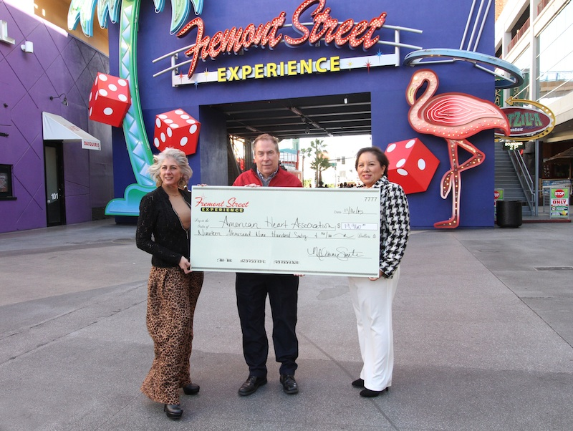
Photo Caption: From left to right: Gina Mann, American Heart Association Executive Director; Thomas Bruny, Director of Marketing of Fremont Street Experience; RayAnn Rodriguez, American Heart Association Development Director. Fremont Street Experience presents a check for $19,960 to the American Heart Association. The proceeds were raised from SlotZilla revenue on Nov. 7, 2015. Photo courtesy of Scott Roeben of Fremont Street Experience.

About SlotZilla™
Zip & Zoom – Vegas Style on the world’s most unique zipline – SlotZilla™ at Fremont Street Experience located in Downtown Las Vegas. SlotZilla combines innovative technology with a dynamic themed concept to transcend a traditional zipline ride, becoming a ground-breaking attraction for the amusement industry. The attraction features two thrill levels, a lower Zipline where flyers travel half the length of Fremont Street Experience in a traditional seated-harness position and an upper Zoomline where flyers are launched in a horizontal “superman” position 1,750 feet across the entire length of Fremont Street Experience. Both levels deliver an experience unique in the world – flying above thousands of people on Fremont Street Experience and under the four-block-long Viva Vision canopy, which is the world’s largest video screen.

SlotZilla is open Sundays through Thursdays from noon to midnight, and Fridays and Saturdays from noon to 2 a.m. Flights are $20 for the lower Zipline and $40 for the upper Zoomline. Flight times can be booked in advance at the SlotZilla ticketing, will call & check-in office located at 425 Fremont St., Ste. 160. Advance ticket purchases can also be made online at www.vegasexperience.com or by calling 1-844-ZIPVEGAS. Advance group sales for 20 or more tickets can be made by calling (702) 678-5780 or 1-844-SLOTZILLA.

Visit online at www.vegasexperience.com, Facebook: facebook.com/SlotZillaLasVegas, Twitter: @SlotZillaLV, or Yelp: http://www.yelp.com/biz/slotzilla-las-vegas

MEDIA CONTACTS:
Lauren Silverstein
Preferred Public Relations
702-254-5704
Lauren@preferredpublicrelations.com

