FOR IMMEDIATE RELEASE

Fremont Street Experience to Host Gary Sinise & The Lt. Dan Band
Salute To The Troops Free Concert

Disabled Veterans Travel to Vegas from Walter Reed at Naval Support Activity Bethesda & Fort Belvoir

Click to Tweet: http://ctt.ec/Q6H0x Come commemorate our vets at a rockin’ #VeteransDay free concert with @FSELV on 11/14 featuring @GarySinise & Lt. Dan Band!
Las Vegas, NV – October 28, 2015 – Fremont Street Experience will host, for the third year, a special post-Veterans Day free concert featuring actor/humanitarian Gary Sinise’s Lt. Dan Band. Gary Sinise & The Lt. Dan Band’s “Salute To The Troops” concert at Fremont Street Experience will be Saturday, Nov. 14, at 7:30 p.m. on the 1st Street Stage The event will kick off with the Nellis Air Force Base Color Guard and Lt. Daniel Vargas singing the National Anthem.
A program of the Gary Sinise Foundation, the Lt. Dan Band has a singular mission when it puts on a concert: Honor. Gratitude. Rock and Roll. It’s a high energy performance as the twelve-member group covers hits from classic to contemporary, featuring the songs of Stevie Wonder, Kelly Clarkson, Adele, the Zac Brown Band, and more – there are even swing tunes from the 1940's. You name it, there’s something for everyone. Whether boosting morale on military bases at home and abroad, raising awareness at benefit concerts across the country, or headlining a Gary Sinise Foundation Invincible Spirit Festival, the band entertains and inspires and it is Gary's mission to deliver a message of giving back to our defenders wherever the band performs.

In addition to the Gary Sinise Foundation, this year’s event is made possible thanks to sponsors American Airlines, MGM Resorts International, USO Metro, Fort Worth Airpower Foundation, and Fremont Street Experience.

“Every year we like to show our gratitude for all that our active and retired military have sacrificed and continue to sacrifice for our country, said Tom Bruny, Director of Marketing of Fremont Street Experience. We are thrilled to have Gary Sinise & The Lt. Dan Band return to Fremont Street Experience for the third year and be a part of this special tribute to our soldiers. We are also honored that we could welcome affected soldiers from around the country to enjoy this special concert.”

Sinise, who played Lt. Dan Taylor in the movie Forrest Gump and starred on the long running TV show CSI: NY, is founder of the Gary Sinise Foundation, an organization dedicated to helping and honoring U.S. service members, veterans, first responders and their families. His band has performed for troops all over the world. The concert is free and open to the public. A VIP area will be set up in front of the stage to be exclusively used by approximately 150 disabled veterans from both Walter Reed at Naval Support Activity Bethesda & Fort Belvoir. This trip is sponsored & produced by American Airlines, which charters a plane to fly the disabled veterans to Las Vegas. The Mirage is their host hotel while in Vegas and Landry’s Bubba Gump restaurant at Planet Hollywood will be hosting them for a pre-concert dinner.

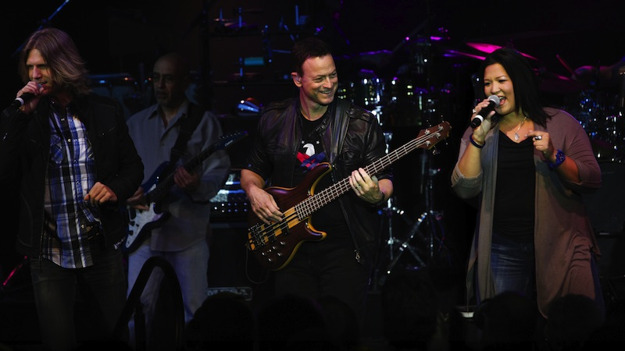
Photo #1: Gary Sinise and his Lt. Dan Band perform. Photo credit: GarySiniseFoundation.org

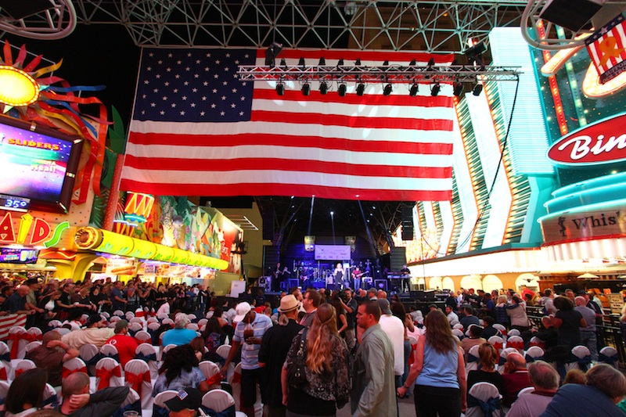
Photo #2: A VIP area for approximately 150 disabled veterans from both Walter Reed at Naval Support Activity Bethesda & Fort Belvoir at the Lt. Dan Band “Salute the Troops” free concert at Fremont Street Experience on November 8, 2014. Photo credit: Scott Roeben of Fremont Street Experience.

About Gary Sinise and Gary Sinise Foundation
Actor/humanitarian Gary Sinise has been actively and tirelessly supporting the troops for over thirty years. Among his numerous film and television roles, it was his portrayal of Lt. Dan Taylor in the landmark film Forrest Gump which formed an enduring connection with servicemen and women throughout the military community. After several USO handshake tours in 2003, Sinise formed the “Lt. Dan Band” and began entertaining troops serving at home and abroad. Performing pop hits to classic rock staples, the 12-member cover band has played for over half-a-million troops and their families. His endless work on behalf of those who’ve served has earned Sinise many distinguished awards including The Bob Hope Award for Excellence in Entertainment from the Medal of Honor Society, the Spirit of the USO Award, The Ellis Island Medal of Honor, the Spirit of Hope Award by the Department of Defense, and most recently the Dwight D. Eisenhower Award from the National Defense Industrial Association. He is the 2015 recipient of the Sylvanus Thayer award from the West Point Association of Graduates and in 2008 he received the Presidential Citizens Medal, the second-highest civilian honor awarded to citizens for exemplary deeds performed in service of the nation, only the third actor ever to receive this honor. He was named an Honorary Chief Petty Officer by the United States Navy and an Honorary Marine by the United States Marine Corp.

In 2011, Sinise started the Gary Sinise Foundation with a mission to honor defenders, veterans, first responders, their families and those in need by creating and supporting unique programs designed to entertain, educate, inspire, strengthen and build communities. These include its R.I.S.E. program (Restoring Independence and Supporting Empowerment), whose flagship initiative is a specially adapted custom Smart Home building project for severely wounded veterans. Each home is customized to ease daily challenges and help restore independence with features like retractable cook tops, cabinets and shelving, elevators and more, all accessible via an iPad. The Gary Sinise Foundation is constructing these one-of-a-kind homes all across the country, each for a wounded hero, their caregivers and family. Other programs include Relief & Resiliency Outreach, Soaring Valor, Invincible Spirit Festivals, and Arts & Entertainment Outreach. Over the years, the Foundation has formed numerous corporate partnerships that support many of the Foundation’s programs.
The Gary Sinise Foundation (Federal Tax ID 80-0587086) is a 501(c)(3) tax-exempt charity as defined in sections 509(A)(1) and 170(B)(1)(A)(VI) of the Internal Revenue Code. Combined Federal Campaign, CFC #27963. For more information, visit garysinisefoundation.org.
About Fremont Street Experience
Fremont Street Experience, a five-block entertainment district located in historic downtown Las Vegas features Viva Vision, North America’s largest video screen - 1,500 feet long, 90 feet wide and suspended 90 feet above the urban pedestrian mall. Viva Vision features nightly spectacular light and sounds shows with 12.5 million LED lights and a 550,000-watt sound system. Fremont Street Experience is a one-of-a-kind venue that includes free nightly concerts and entertainment on three stages. SlotZilla, the world’s most unique zipline attraction, features the 850-foot long Zipline and the 1,750-foot long Zoomline as people launch from a 12-story slot-machine themed takeoff platform to fly under the Viva Vision canopy. With direct pedestrian access to 10 casinos, more than 60 restaurants and specialty retail kiosks, Fremont Street Experience attracts more than 14 million annual visitors. Fremont Street Experience can be found online at www.vegasexperience.com.

“Like” Fremont Street Experience on Facebook: https://www.facebook.com/FSE89101
“Follow” Fremont Street Experience (@FSELV) on Twitter: https://twitter.com/FSELV

###

MEDIA CONTACTS:
Lauren Silverstein
Preferred Public Relations
702-254-5704
Lauren@preferredpublicrelations.com

