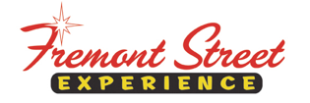

FOR IMMEDIATE RELEASE

Fremont Street Experience Presents Three Square Food Bank a Check for $10,660 Raised from SlotZilla™ Revenue

Las Vegas, Nev. – August 4, 2015 – Fremont Street Experience hosted a SlotZilla Charity Challenge to benefit Three Square Food Bank. On Thursday, July 16 from 1 p.m. – 7 p.m., 100% of SlotZilla revenue from flights on the lower Zipline ($20) or upper Zoomline ($40) went to Three Square. President of Fremont Street Experience, Jeff Victor, and Fremont Street Experience Director of Marketing, Tom Bruny, presented Three Square a check for $10,660 on Tuesday, July 28, 2015.

“We are honored that so many people came down to fly on SlotZilla and support this great charity, said Jeff Victor, president of Fremont Street Experience. “This was a great way for members of the community to give back to Three Square and with the money we raised, over 30,000 meals were created for people in need.”

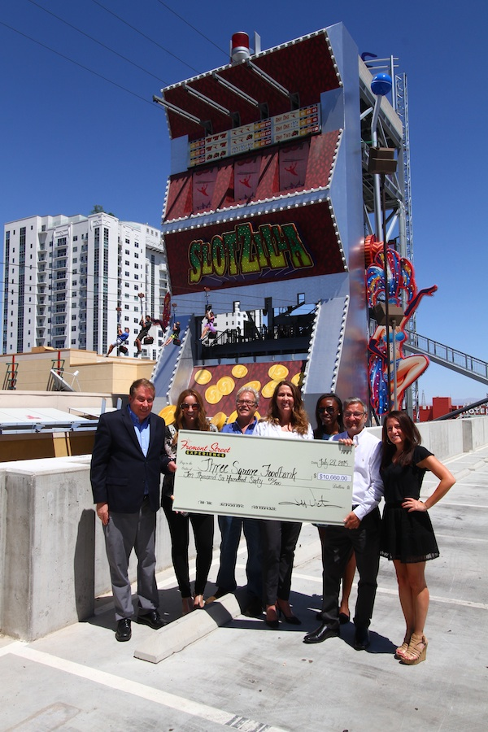
Photo #1: (From left to right: Tom Bruny, Director of Marketing of Fremont Street Experience; Jen Sayer, Three Square Marketing Manager; Dan Johnson, Three Square Development Officer; Michelle Beck, Three Square Development Officer; Alana Shaul, Three Square External Events Coordinator; Jeff Victor, President of Fremont Street Experience; Kari Goldberg, Three Square External Events Specialist). Fremont Street Experience presents a check for $10,660 to Three Square. The proceeds were raised from SlotZilla revenue on July 16, 2015. Photo courtesy of Scott Roeben of Fremont Street Experience.
About SlotZilla™
Zip & Zoom – Vegas Style on the world’s most unique zipline – SlotZilla™ at Fremont Street Experience located in Downtown Las Vegas. SlotZilla combines innovative technology with a dynamic themed concept to transcend a traditional zipline ride, becoming a ground-breaking attraction for the amusement industry. The attraction features two thrill levels, a lower Zipline where flyers travel half the length of Fremont Street Experience in a traditional seated-harness position and an upper Zoomline where flyers are launched in a horizontal “superman” position 1,750 feet across the entire length of Fremont Street Experience. Both levels deliver an experience unique in the world – flying above thousands of people on Fremont Street Experience and under the four-block-long Viva Vision canopy, which is the world’s largest video screen.

SlotZilla is open Sundays through Thursdays from noon to midnight, and Fridays and Saturdays from noon to 2 a.m. Flights are $20 for the lower Zipline and $40 for the upper Zoomline. Flight times can be booked in advance at the SlotZilla ticketing, will call & check-in office located at 425 Fremont St., Ste. 160. Advance ticket purchases can also be made online at www.vegasexperience.com or by calling 1-844-ZIPVEGAS. Advance group sales for 20 or more tickets can be made by calling (702) 678-5780 or 1-844-SLOTZILLA.

Visit online at www.vegasexperience.com, Facebook: facebook.com/SlotZillaLasVegas, Twitter: @SlotZillaLV, or Yelp: http://www.yelp.com/biz/slotzilla-las-vegas

MEDIA CONTACTS:
Lauren Silverstein
Preferred Public Relations
702-254-5704
Lauren@preferredpublicrelations.com

