FOR IMMEDIATE RELEASE

Fremont Street Experience and The Dave, Mahoney and DK Morning Show Present St. Jude’s Ranch
a Check for $13,380 from SlotZilla Charity Challenge

St. Jude’s Ranch for Children sets a new weekday SlotZilla Charity Challenge record for the most money raised

Las Vegas, NV – Aug. 19, 2015 – Fremont Street Experience and The Dave, Mahoney and DK Morning show on X107.5, hosted a SlotZilla Charity Challenge to benefit St. Jude’s Children’s Ranch. On Monday, Aug. 10 from noon – 6 p.m., 100% of SlotZilla revenue from flights on the lower Zipline ($20) or upper Zoomline ($40) went to St. Jude’s Ranch. The Dave, Mahoney and DK Morning Show, Fremont Street Experience President Jeff Victor and Fremont Street Experience Director of Marketing Tom Bruny presented St. Jude’s Ranch for Children a check for $13,380 on Wednesday, Aug. 19.

“We are honored to have partnered with The Dave, Mahoney and DK Morning Show for their last charity event in Las Vegas before their move to Mix 96.5 in Houston,” said Victor. “So many people came down to fly on SlotZilla and support St. Jude’s Ranch for Children. We ended up breaking the largest weekday SlotZilla Charity Challenge record with $13,380 and all of that money will be going to help the children at St. Jude’s Ranch as they get ready to go back to school.”

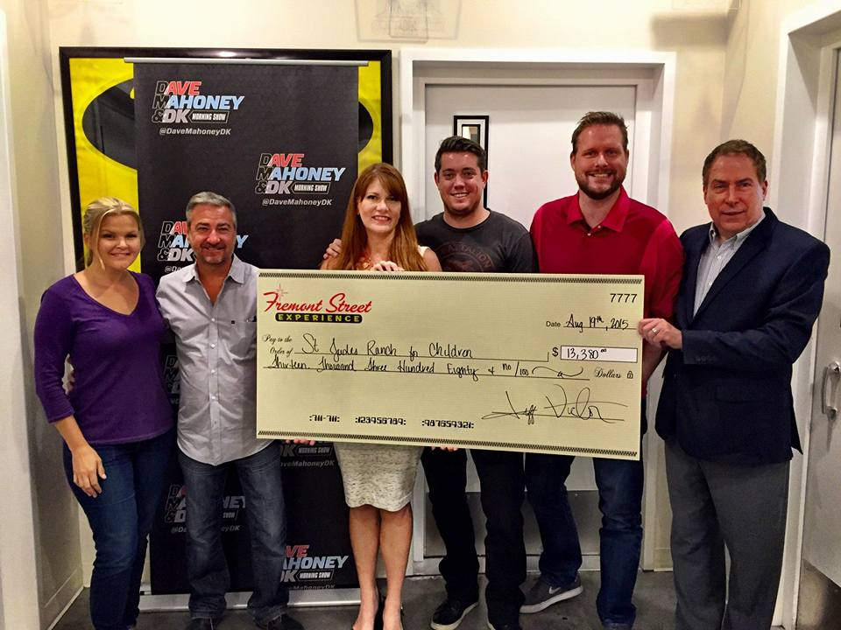
Photo #1: (From left to right: Daena Kramer, Host of The Dave, Mahoney and DK Morning Show on X107.5; Jeff Victor, President of Fremont Street Experience; Pamela Carlston, St. Jude’s Ranch for Children Director of Development; Dave Farra, Host of The Dave, Mahoney and DK Morning Show on X107.5; Jason Mahoney, Host of The Dave, Mahoney and DK on X107.5; Tom Bruny, Director of Marketing of Fremont Street Experience). Fremont Street Experience and the Dave, Mahoney and DK Morning Show present a check for $13,380 to St. Jude’s Ranch for Children. The proceeds were raised from SlotZilla revenue on Aug. 10, 2015.

About St. Jude’s Ranch for Children
The mission of St. Jude’s Ranch for Children is to serve all abused, abandoned, and neglected children and families, creating new chances, new choices, and new hope in a safe homelike environment. Children are placed at the Ranch when their parents or caretakers are unable or unfit to adequately care for them. One of the most important features of the Ranch is the ability to keep large sibling groups together when they might otherwise be separated and scattered among several foster homes. For additional information, visit www.stjudesranch.org.

About SlotZilla™
Zip & Zoom – Vegas Style on the world’s most unique zipline – SlotZilla™ at Fremont Street Experience located in Downtown Las Vegas. SlotZilla combines innovative technology with a dynamic themed concept to transcend a traditional zipline ride, becoming a ground-breaking attraction for the amusement industry. The attraction features two thrill levels, a lower Zipline where flyers travel half the length of Fremont Street Experience in a traditional seated-harness position and an upper Zoomline where flyers are launched in a horizontal “superman” position 1,750 feet across the entire length of Fremont Street Experience. Both levels deliver an experience unique in the world – flying above thousands of people on Fremont Street Experience and under the four-block-long Viva Vision canopy, which is North America’s largest video screen.

SlotZilla is open Sundays through Thursdays from noon to midnight, and Fridays and Saturdays from noon to 2 a.m. Flights are $20 for the lower Zipline and $40 for the upper Zoomline. Flight times can be booked in advance at the SlotZilla ticketing, will call & check-in office located at 425 Fremont St., Ste. 160. Advance ticket purchases can also be made online at www.vegasexperience.com or by calling 1-844-ZIPVEGAS. Advance group sales for 20 or more tickets can be made by calling (702) 678-5780 or 1-844-SLOTZILLA.

Visit online at www.vegasexperience.com, Facebook: facebook.com/SlotZillaLasVegas, Twitter: @SlotZillaLV, or Yelp: http://www.yelp.com/biz/slotzilla-las-vegas

MEDIA CONTACT:
Lauren Silverstein
Preferred Public Relations
702-254-5704
Lauren@preferredpublicrelations.com

