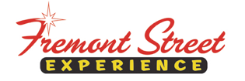

FOR IMMEDIATE RELEASE

Fremont Street Experience Goes Patriotic with
Fourth of July Festivities

Celebrate Fourth of July weekend at Fremont Street Experience with performances by Madison Rising and virtual fireworks on the Viva Vision canopy

LAS VEGAS, NV – June 30, 2015 – Las Vegas’ famed Fremont Street Experience invites all to come out and celebrate the Fourth of July with a weekend of free concerts and virtual fireworks. The festivities include performances from patriotic band, Madison Rising, on Friday, July 3 and Saturday, July 4 from 9:10 p.m. – 10:40 p.m. on the 1st Street Stage at Fremont Street Experience in exciting downtown Las Vegas. Additionally, visual fireworks and patriotic images – set to some of America’s favorite songs – will be shown overhead on Viva Vision on July 3 and July 4 following each regular Viva Vision show between 8 p.m. – 1 a.m.

Fremont Street Experience’s Fourth of July weekend festivities are free and open to the public. Downtown Las Vegas is the perfect place for everyone to come celebrate our Nation’s birthday.

About Madison Rising
Led by U.S. Navy and Marine Corps Veteran, Dave Bray, Madison Rising is on a mission to honor the American spirit through patriotic rock n' roll. In 2012 Madison Rising found instant success with their rock rendition of the “Star Spangled Banner.”
The band recently released their completely remastered album- “American Hero - R.E.D.” The album is proudly dedicated to the men and women of our armed forces and first responders for their sacrifice and selfless dedication to the land of the free and home of the brave. Madison Rising strives to create music with meaning and songs that are about something such as our military, sacrifice, freedom, liberty, gratitude, and living the American dream. Please Support Madison Rising Shows For Heroes: http://madisonrisingshowsforheroes.com. Music available at: iTunes, Amazon and www.madisonrising.com

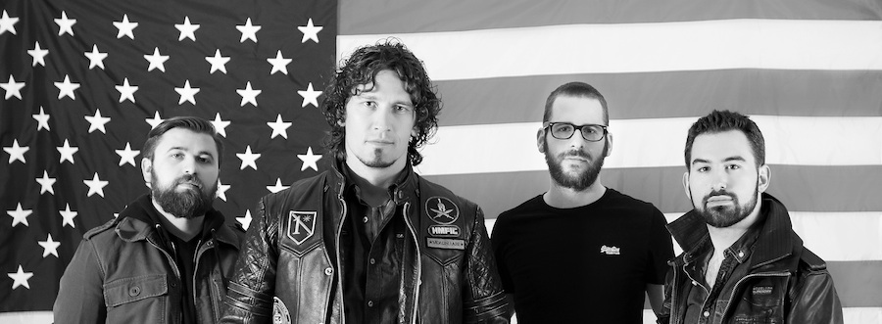
Photo #1: Madison Rising will perform two free concerts during Fremont Street Experience’s 4th of July weekend festivities. They will be performing on the 1st Street Stage on Friday, July 3 and Saturday, July 4 from 9:10 p.m. – 10:40 p.m.

About Fremont Street Experience
Fremont Street Experience, a five-block entertainment district located in historic downtown Las Vegas features Viva Vision, the world’s largest video screen - 1,500 feet long, 90 feet wide and suspended 90 feet above the urban pedestrian mall. Viva Vision features nightly spectacular light and sounds shows with 12.5 million LED lights and a 550,000-watt sound system. Fremont Street Experience is a one-of-a-kind venue that includes free nightly concerts and entertainment on three stages. SlotZilla, the world’s most unique zipline attraction, features the 850-foot Zipline and the 1,750-foot Zoomline as people launch from a 12-story slot-machine themed takeoff platform to fly under the Viva Vision canopy. With direct pedestrian access to 8 casinos, more than 60 restaurants and specialty retail kiosks, Fremont Street Experience attracts more than 17 million annual visitors. Fremont Street Experience can be found online at www.vegasexperience.com.

“Like” Fremont Street Experience on Facebook: https://www.facebook.com/FSE89101
“Follow” Fremont Street Experience (@FSELV) on Twitter: https://twitter.com/FSELV

###

MEDIA CONTACT:
Lauren Silverstein
Preferred Public Relations
702-254-5704
Lauren@preferredpublicrelations

