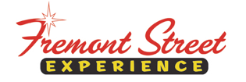

FOR IMMEDIATE RELEASE

Tonic and Vertical Horizon to Perform Free Concert
at Fremont Street Experience

Rock of Vegas Summer Concert Series Continues May 30

Click to Tweet: http://ctt.ec/4_2Z3 Check out @tonicband and @VerticalHorizon as they perform a free concert @FSELV on Sat. 5/30 at 9PM. #RockofVegas #FreeConcert

LAS VEGAS, NV – May 26, 2015 – Headlining bands, Tonic and Vertical Horizon will perform a free concert during Fremont Street Experience’s Rock of Vegas summer concert series on Saturday, May 30 at 9 p.m. at the 1st Street Stage. Celebrating its seventh season, the free concerts have become one of the most popular summertime events in Las Vegas. This year’s lineup will turn the legendary downtown Las Vegas entertainment venue into summer’s alternative destination through Labor Day weekend with a free concert series that showcases a stellar lineup of bands that have taken music to the edge.

Tonic
Tonic stormed the charts with their debut album, Lemon Parade and its monster hit, “If You Could Only See.” They continued their streak by releasing two additional studio albums, Sugar and Head on Straight, the latter of which was nominated for a Grammy. The band’s lead single, “You Wanted More,” was also featured in the movie, “American Pie.” With more than six Top 10 singles, more than 4 million records sold, two Grammy nominations and numerous awards, platinum albums and hit songs around the world, Tonic is a musical powerhouse.

Vertical Horizon
Alt rock favorites Vertical Horizon signed with RCA in 1999 and experienced meteoric success with Everything You Want, selling over two million copies. The title song captured the #1 spot on Billboard’s Hot 100 and Adult Top 40 charts, and went on to become the most played single of 2000. Burning the Days, Vertical Horizon’s newest studio album, is a true testament to their commitment to making brilliant music.

For complete information on the headliner concerts and nightly entertainment, visit www.vegasexperience.com.

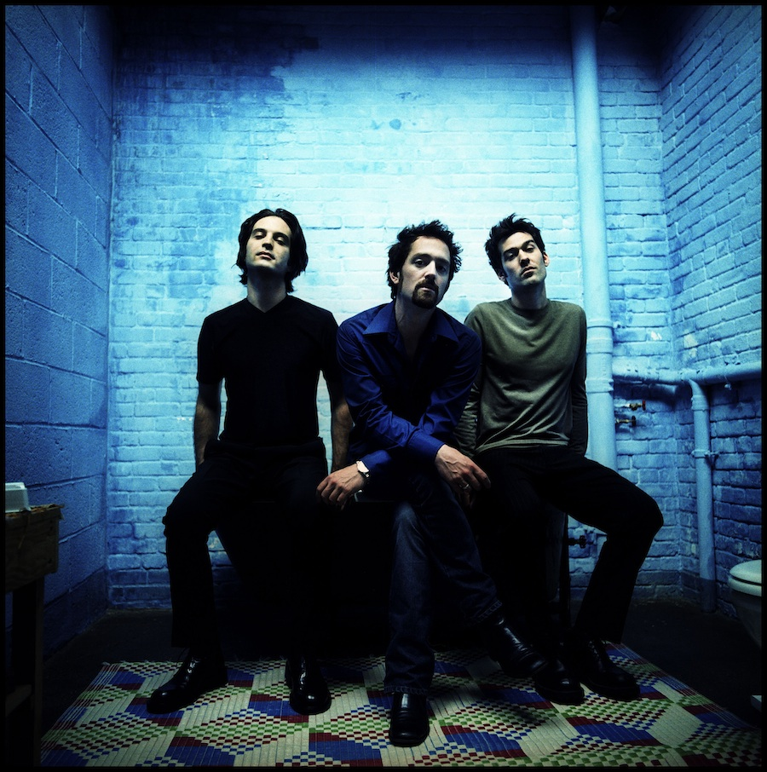
Photo #1: Tonic will perform a free concert during Fremont Street Experience’s Rock of Vegas summer concert series on Saturday, May 30 at 9 p.m. at the 1st Street Stage.

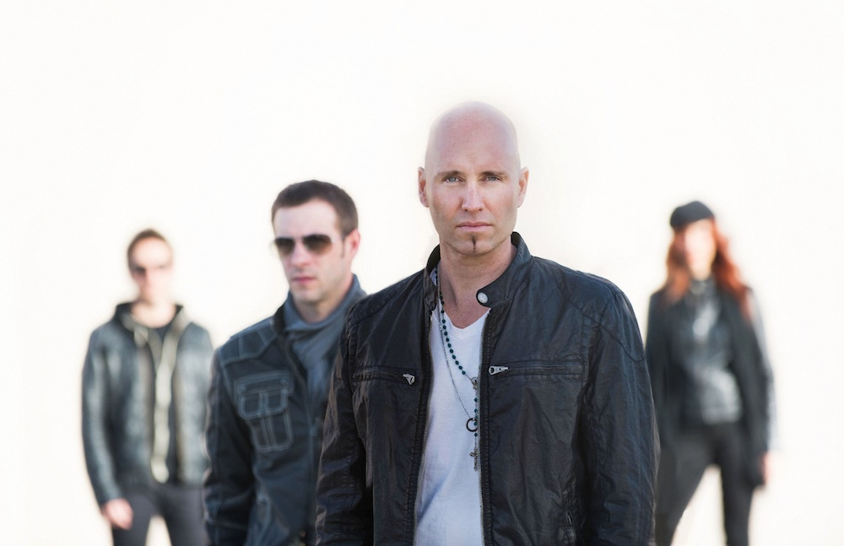
Photo #2: Vertical Horizon will perform a free concert during Fremont Street Experience’s
Rock of Vegas summer concert series on Saturday, May 30 at 9 p.m. at the 1st Street Stage.

Rock of Vegas Concert Series
Throughout the summer, Fremont Street Experience will provide the ultimate nirvana for rock music fans with an exciting lineup of performances that include: Tonic and Vertical Horizon on May 30; Martha Davis and The Motels, The Tubes and The Smithereens on June 13; Smash Mouth and Toad the Wet Sprocket on June 27; UFC Fight Week concert on July 10; Theory of a Deadman on July 18; Spin Doctors and Cherry Poppin’ Daddies on Aug. 1; and Kansas and Blue Oyster Cult on Sept. 6. All concerts start at 9 p.m.

About Fremont Street Experience
Fremont Street Experience, a five-block entertainment district located in historic downtown Las Vegas features Viva Vision, the world’s largest video screen - 1,500 feet long, 90 feet wide and suspended 90 feet above the urban pedestrian mall. Viva Vision features nightly spectacular light and sounds shows with 12.5 million LED lights and a 550,000-watt sound system. Fremont Street Experience is a one-of-a-kind venue that includes free nightly concerts and entertainment on three stages. SlotZilla, the world’s most unique zipline attraction, features the 850-foot Zipline and the 1,750-foot Zoomline as people launch from a 12-story slot-machine themed takeoff platform to fly under the Viva Vision canopy. With direct pedestrian access to 8 casinos, more than 60 restaurants and specialty retail kiosks, Fremont Street Experience attracts more than 17 million annual visitors. Fremont Street Experience can be found online at www.vegasexperience.com.

“Like” Fremont Street Experience on Facebook: https://www.facebook.com/FSE89101
“Follow” Fremont Street Experience (@FSELV) on Twitter: https://twitter.com/FSELV
###
MEDIA CONTACT:
Lauren Silverstein/James Woodrow
Preferred Public Relations
702-254-5704
Lauren@preferredpublicrelations
James@preferredpublicrelations.com

