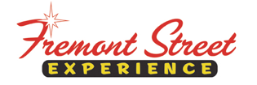

FOR IMMEDIATE RELEASE

Fremont Street Experience Presents the Muscular Dystrophy Association a Check for $6,800 Raised from SlotZilla™ Revenue

Las Vegas, Nev. – May 4, 2015 – Fremont Street Experience partnered with the Muscular Dystrophy Association and the Firefighters of Southern Nevada for a SlotZilla Charity Challenge. On Thursday, April 16 from noon – 6 p.m., 100% of SlotZilla revenue went to the MDA from everyone that flew on either the lower Zipline ($20) or upper Zoomline ($40). President of Fremont Street Experience, Jeff Victor, and Fremont Street Experience Director of Marketing, Tom Bruny, presented the MDA and the Firefighters of Southern Nevada a check for $6,800 on Friday, May 1, 2015 at the Fill the Boot press conference.

“We are honored that so many people came down to fly on SlotZilla and support this great charity,” said Jeff Victor, president of Fremont Street Experience. “We support the Firefighters of Southern Nevada boot drive that takes place every year to raise money for the MDA. This event was a fantastic way for supporters to come down to Fremont Street and have a great time for a great cause.”

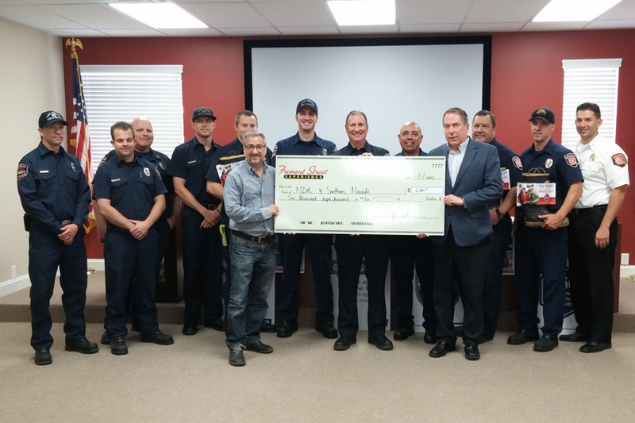

Photo #1: (Left of Check, Jeff Victor, President of Fremont Street Experience; Right of Check, Tom Bruny, Director of Marketing of Fremont Street Experience). Fremont Street Experience presents a check for $6,800 to the Muscular Dystrophy Association with the Firefighters of Southern Nevada at the Fill the Boot press conference on Friday, May 1. The proceeds were raised from SlotZilla revenue on April 16, 2015.

About SlotZilla™
Zip & Zoom – Vegas Style on the world’s most unique zipline – SlotZilla™ at Fremont Street Experience located in Downtown Las Vegas. SlotZilla combines innovative technology with a dynamic themed concept to transcend a traditional zipline ride, becoming a ground-breaking attraction for the amusement industry. The attraction features two thrill levels, a lower Zipline where flyers travel half the length of Fremont Street Experience in a traditional seated-harness position and an upper Zoomline where flyers are launched in a horizontal “superman” position 1,750 feet across the entire length of Fremont Street Experience. Both levels deliver an experience unique in the world – flying above thousands of people on Fremont Street Experience and under the four-block-long Viva Vision canopy, which is the world’s largest video screen.

SlotZilla is open Sundays through Thursdays from noon to midnight, and Fridays and Saturdays from noon to 2 a.m. Flights are $20 for the lower Zipline and $40 for the upper Zoomline. Flight times can be booked in advance at the SlotZilla ticketing, will call & check-in office located at 425 Fremont St., Ste. 160. Advance ticket purchases can also be made online at www.vegasexperience.com or by calling 1-844-ZIPVEGAS. Advance group sales for 20 or more tickets can be made by calling (702) 678-5780 or 1-844-SLOTZILLA.

Visit online at www.vegasexperience.com, Facebook: facebook.com/SlotZillaLasVegas, Twitter: @SlotZillaLV, or Yelp: http://www.yelp.com/biz/slotzilla-las-vegas

MEDIA CONTACTS:
Lauren Silverstein
Preferred Public Relations
702-254-5704
Lauren@preferredpublicrelations.com

