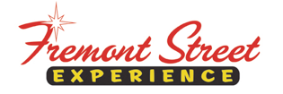

FOR IMMEDIATE RELEASE

Great Scott! It’s Time to Go “Back to the Future” with Las Vegas Car Stars at Fremont Street Experience May 15 – 16

Celebrate the 30 Year Anniversary of Back to the Future with
Christopher Lloyd and Lea Thompson

Las Vegas, NV – May 8, 2015 – The world’s greatest gathering of TV and movie cars will takeover Fremont Street Experience during Las Vegas Car Stars 2015 on Friday, May 15 and Saturday, May 16 with a special 30 Year Anniversary Celebration of Back to the Future. The event will begin on Friday, May 15 with a warm welcome from Clark County Commissioner Lawrence Weekly, Clark County Commissioner Tom Collins and LVCVA President/CEO Rossi Ralenkotter at the Welcome to Las Vegas Sign followed by a parade of cars from hit shows and films. The festivities will continue at Fremont Street Experience where visitors can line up to see the legendary cars. Mayor Carolyn Goodman and Ralenkotter will kick off the Opening Ceremony at 5 p.m. on Fremont Street Experience’s 3rd Street Stage. The entertainment on Saturday, May 16 will include tributes to Back to the Future and feature appearances by Christopher Lloyd, Lea Thompson and other cast members.

Las Vegas Car Stars will pay homage to original television and movies recognized worldwide and features cars from the following hit shows and films: Back to the Future DeLorean, Batman Batmobile, Starsky & Hutch Movie Hero Cars, The A-Team van, Herbie from The Love Bug, Ghostbusters 1959 Cadillac and more. The event will also host a special meet and greet with various celebrities including Christopher Lloyd, Lea Thompson, Back to the Future writer Bob Gale, Jaws cast member Susan Backlinie, famed stuntman Bob Bralver and more.

Las Vegas Car Stars and vintage, hotrod and classic car owners participating in the event will be raising money for the Children’s Miracle Network, a nationally recognized charity that assists children and their families in need.

The schedule of events is as follows:

Las Vegas Car Stars Press Conference – Friday, May 15
- 5-6:30 p.m. – Press Conference (3rd Street Stage); Oscar Goodman Proclamation, Las Vegas Car Stars lined up along Fremont Street Experience, Celebrity appearances.

Las Vegas Car Stars Day – Saturday, May 16
- 10 a.m. – Opening ceremony
- 10 a.m. – 4:30 p.m. – Celebrity cars on display, celebrity appearances and autographs (11 a.m. – 1 p.m.), Q & A session (1 p.m. – 2 p.m.),
Back to the Future tributes

For more information on Las Vegas Car Stars visit www.LasVegasCarStars.com. For more information on other Fremont Street Experience events, visit www.vegasexperience.com.

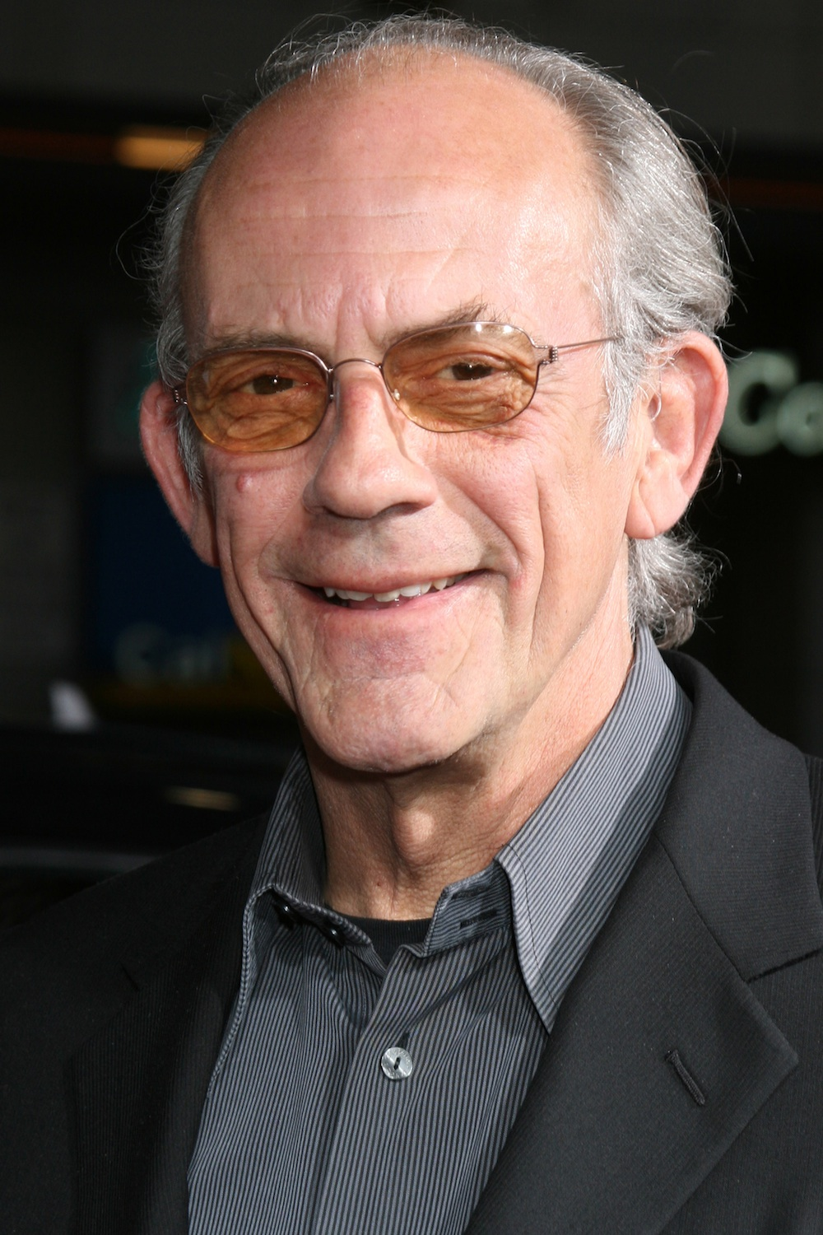
Photo # 1: Back to the Future actor Christopher Lloyd who played the legendary Doc Brown, will make an appearance at Las Vegas Car Stars 2015 at Fremont Street Experience.
About Fremont Street Experience
Fremont Street Experience, a five-block entertainment district located in historic downtown Las Vegas features Viva Vision, the world’s largest video screen - 1,500 feet long, 90 feet wide and suspended 90 feet above the urban pedestrian mall. Viva Vision features nightly spectacular light and sounds shows with 12.5 million LED lights and a 550,000-watt sound system. Fremont Street Experience is a one-of-a-kind venue that includes free nightly concerts and entertainment on three stages. SlotZilla, the world’s most unique zipline attraction, features the 850-foot Zipline and the 1,750-foot Zoomline as people launch from a 12-story slot-machine themed takeoff platform to fly under the Viva Vision canopy. With direct pedestrian access to 8 casinos, more than 60 restaurants and specialty retail kiosks, Fremont Street Experience attracts more than 17 million annual visitors. Fremont Street Experience can be found online at www.vegasexperience.com.

“Like” Fremont Street Experience on Facebook: https://www.facebook.com/FSE89101
“Follow” Fremont Street Experience (@FSELV) on Twitter: https://twitter.com/FSELV

MEDIA CONTACT:
Lauren Silverstein/James Woodrow
Preferred Public Relations
702-254-5704
Lauren@preferredpublicrelations.com
James@preferredpublicrelations.com

