FOR IMMEDIATE RELEASE

Fremont Street Experience Presents Ronald McDonald House Charities a Check for $7,020 Raised from SlotZilla™ Revenue

Las Vegas, Nev. – March 16, 2015 – Fremont Street Experience partnered with Ronald McDonald House Charities for a SlotZilla Charity Challenge. On Thursday, February 26 from noon – 6 p.m., 100% of SlotZilla revenue went to Ronald McDonald House charities from everyone that flew on either the lower Zipline ($20) or upper Zoomline ($40). President of Fremont Street Experience, Jeff Victor, and Fremont Street Experience Director of Marketing, Tom Bruny, presented Ronald McDonald House charities a check for $7,020 on Thursday, March 12, 2015.

“We are honored that so many people came down to fly on SlotZilla and support this great charity, said Jeff Victor, president of Fremont Street Experience. “This was a great way for members of the community to give back to RMHC which believe every child deserves a comfortable and supportive place to grow by creating and supporting programs to improve a child’s well-being.”

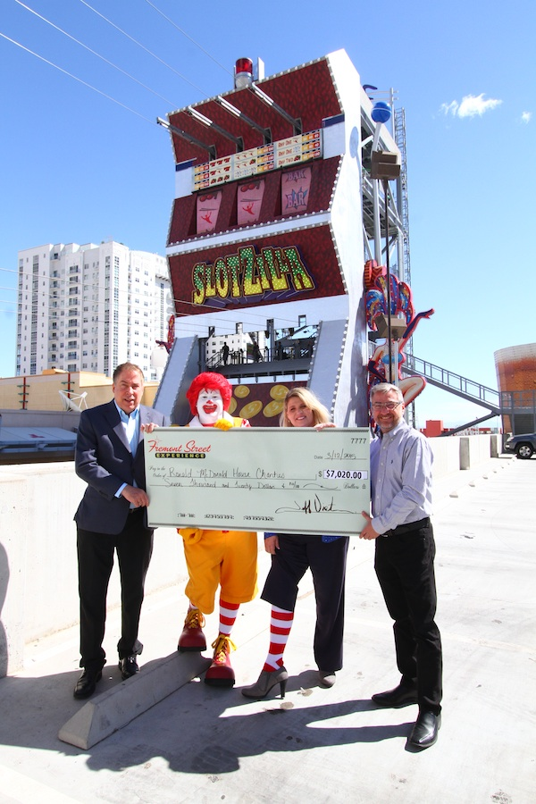
Photo #1: (From left to right: Tom Bruny, Director of Marketing of Fremont Street Experience; Ronald McDonald; Alyson McCarthy, Executive Director of Ronald McDonald House Charities; Jeff Victor, President of Fremont Street Experience). Fremont Street Experience presents a check for $7,020 to Ronald McDonald House Charities. The proceeds were raised from SlotZilla revenue on February 26, 2015. Photo courtesy of Scott Roeben of Fremont Street Experience.
About SlotZilla™
Zip & Zoom – Vegas Style on the world’s most unique zipline – SlotZilla™ at Fremont Street Experience located in Downtown Las Vegas. SlotZilla combines innovative technology with a dynamic themed concept to transcend a traditional zipline ride, becoming a ground-breaking attraction for the amusement industry. The attraction features two thrill levels, a lower Zipline where flyers travel half the length of Fremont Street Experience in a traditional seated-harness position and an upper Zoomline where flyers are launched in a horizontal “superman” position 1,750 feet across the entire length of Fremont Street Experience. Both levels deliver an experience unique in the world – flying above thousands of people on Fremont Street Experience and under the four-block-long Viva Vision canopy, which is the world’s largest video screen.

SlotZilla is open Sundays through Thursdays from noon to midnight, and Fridays and Saturdays from noon to 2 a.m. Flights are $20 for the lower Zipline and $40 for the upper Zoomline. Flight times can be booked in advance at the SlotZilla ticketing, will call & check-in office located at 425 Fremont St., Ste. 160. Advance ticket purchases can also be made online at www.vegasexperience.com or by calling 1-844-ZIPVEGAS. Advance group sales for 20 or more tickets can be made by calling (702) 678-5780 or 1-844-SLOTZILLA.

Visit online at www.vegasexperience.com, Facebook: facebook.com/SlotZillaLasVegas, Twitter: @SlotZillaLV, or Yelp: http://www.yelp.com/biz/slotzilla-las-vegas

MEDIA CONTACTS:
Lauren Silverstein/James Woodrow
Preferred Public Relations
702-254-5704
Lauren@preferredpublicrelations.com
James@preferredpublicrelations.com

