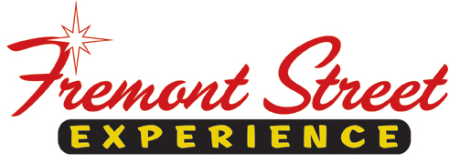

FOR IMMEDIATE RELEASE

Fremont Street Experience Presents the Firefighters of Southern Nevada Burn Foundation a Check for $4,120
Raised from SlotZilla™ Revenue

Las Vegas, Nev. – Jan. 30, 2014 – Fremont Street Experience partnered with the Firefighters of Southern
Nevada Burn Foundation for the first SlotZilla Charity Challenge of 2015. On Thursday, Jan. 15 from
noon – 6 p.m., 100% of SlotZilla revenue went to the Burn Foundation from everyone that flew on either
the lower Zipline ($20) or upper Zoomline ($40). President of Fremont Street Experience, Jeff Victor, and
Director of Marketing, Tom Bruny, presented the Firefighters of Southern Nevada Burn Foundation a check
for $4,120 on Thursday, Jan. 29.

“We are honored to be giving back to the firefighters of Southern Nevada, especially for all that they do for the community,” said Jeff Victor, president of Fremont Street Experience. “This money will be used to send child burn victims to a camp in Northern Nevada so they can interact with other children and build their
self-esteem. We are extremely happy to support this great cause and help out these children in need.”

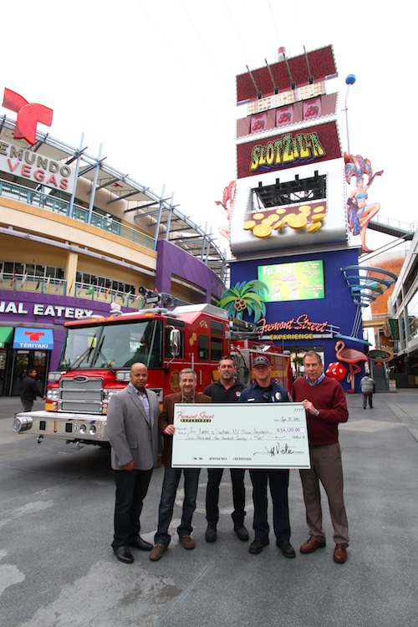
Photo #1: Tom Bruny (Right), Director of Marketing of Fremont Street Experience, and Jeff Victor (2nd from Left), President of Fremont Street Experience, present the Firefighters of Southern Nevada Burn Foundation a check for $4,120 on Thursday, January 29. The proceeds were raised from SlotZilla revenue on January 15. Photo courtesy of Scott Roeben of Fremont Street Experience.

About SlotZilla™
Zip & Zoom – Vegas Style on the world’s most unique zipline – SlotZilla™ at Fremont Street Experience located in Downtown Las Vegas. SlotZilla combines innovative technology with a dynamic themed concept to transcend a traditional zipline ride, becoming a ground-breaking attraction for the amusement industry. The attraction features two thrill levels, a lower Zipline where flyers travel half the length of Fremont Street Experience in a traditional seated-harness position and an upper Zoomline where flyers are launched in a horizontal “superman” position 1,750 feet across the entire length of Fremont Street Experience. Both levels deliver an experience unique in the world – flying above thousands of people on Fremont Street Experience and under the four-block-long Viva Vision canopy, which is the world’s largest video screen.

SlotZilla is open Sundays through Thursdays from noon to midnight, and Fridays and Saturdays from noon to 2 a.m. Flights are $20 for the lower Zipline and $40 for the upper Zoomline. Flight times can be booked in advance at the SlotZilla ticketing, will call & check-in office located at 425 Fremont St., Ste. 160. Advance ticket purchases can also be made online at www.vegasexperience.com or by calling 1-844-ZIPVEGAS. Advance group sales for 20 or more tickets can be made by calling (702) 678-5780 or 1-844-SLOTZILLA.

Visit online at www.vegasexperience.com, Facebook: facebook.com/SlotZillaLasVegas, Twitter: @SlotZillaLV, or Yelp: http://www.yelp.com/biz/slotzilla-las-vegas

MEDIA CONTACTS:
Lauren Silverstein/James Woodrow
Preferred Public Relations
702-254-5704
Lauren@preferredpublicrelations.com
James@preferredpublicrelations.com

