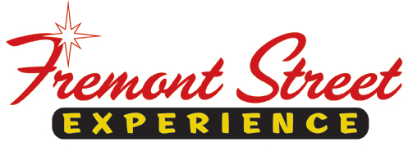

FOR IMMEDIATE RELEASE

Fremont Street Experience Presents Opportunity Village with a Check of $15,068 Raised from SlotZilla™ Revenue

Las Vegas, Nev. – Dec. 30, 2014 – Fremont Street Experience donated 100% of SlotZilla revenue to
Opportunity Village for everyone who flew on either the lower Zipline ($20) or upper Zoomline ($40) on
Saturday, December 6 from 10 a.m. to 5 p.m. in honor of Opportunity Village’s 10th Annual Las Vegas Santa
Run. President of Fremont Street Experience, Jeff Victor, and Director of Marketing, Tom Bruny, presented
Marty Wood, Director of Marketing of Opportunity Village a check of $15,068 on Tuesday, December 23.

About SlotZilla™
Zip & Zoom – Vegas Style on the world’s most unique zipline – SlotZilla™ at Fremont Street Experience located in Downtown Las Vegas. SlotZilla combines innovative technology with a dynamic themed concept to transcend a traditional zipline ride, becoming a ground-breaking attraction for the amusement industry. The attraction features two thrill levels, a lower Zipline where flyers travel half the length of Fremont Street Experience in a traditional seated-harness position and an upper Zoomline where flyers are launched in a horizontal “superman” position 1,750 feet across the entire length of Fremont Street Experience. Both levels deliver an experience unique in the world – flying above thousands of people on Fremont Street Experience and under the four-block-long Viva Vision canopy, which is the world’s largest video screen.

SlotZilla is open Sundays through Thursdays from noon to midnight, and Fridays and Saturdays from noon to 2 a.m. Flights are $20 for the lower Zipline and $40 for the upper Zoomline. Flight times can be booked in advance at the SlotZilla ticketing, will call & check-in office located at 425 Fremont St., Ste. 160. Advance ticket purchases can also be made online at www.vegasexperience.com or by calling 1-844-ZIPVEGAS. Advance group sales for 20 or more tickets can be made by calling (702) 678-5780 or 1-844-SLOTZILLA.

Visit online at www.vegasexperience.com, Facebook: facebook.com/SlotZillaLasVegas, Twitter: @SlotZillaLV, or Yelp: http://www.yelp.com/biz/slotzilla-las-vegas

MEDIA CONTACTS:
Lauren Silverstein/James Woodrow
Preferred Public Relations
702-254-5704
Lauren@preferredpublicrelations.com
James@preferredpublicrelations.com

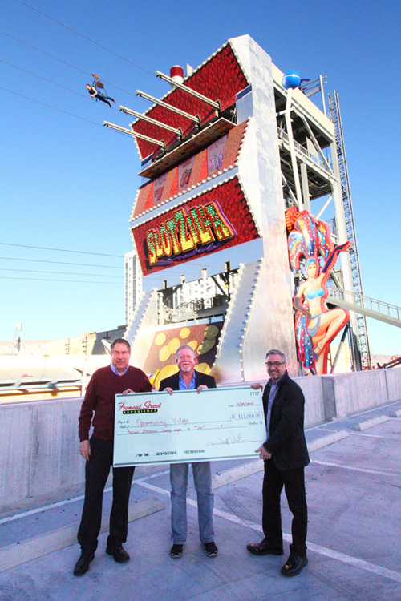

Photo #1: Tom Bruny (Left), Director of Marketing of Fremont Street Experience, and Jeff Victor, President of Fremont Street Experience, present Marty Wood, Director of Marketing of Opportunity Village, a check for $15,068 on Tuesday, December 23. The proceeds were raised from SlotZilla revenue on December 6. Photo courtesy of Scott Roeben of Fremont Street Experience.

