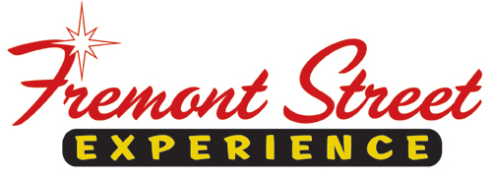

FOR IMMEDIATE RELEASE

Fremont Street Experience Raised $10,000 for Susan G. Komen of Southern Nevada from SlotZilla Revenue on October 30

Las Vegas, Nev. – Nov. 24, 2014 – Fremont Street Experience donated 100% of SlotZilla revenue to
the Southern Nevada office of Susan G. Komen for everyone who flew on either the lower Zipline ($20) or
upper Zoomline ($40) on Thursday, Oct. 30 from noon to 7 p.m. President of Fremont Street Experience, Jeff
Victor, and Director of Marketing, Tom Bruny, presented Stephanie Kirby, Executive Director of Susan G.
Komen of Southern Nevada a check of $10,000 this past Friday, November 21.

“We are excited to be making this donation as a way to give back to the community – specifically Susan G.
Komen which does great work addressing breast cancer on so many levels,” said Jeff Victor, president of
Fremont Street Experience.

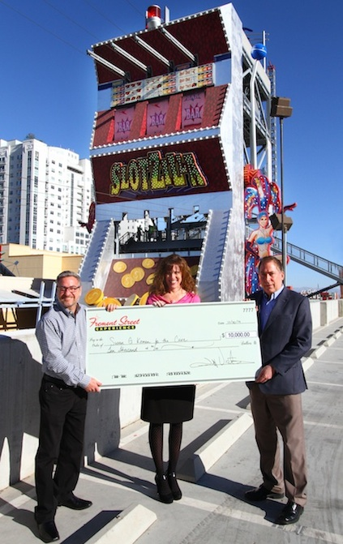
Photo #1: Jeff Victor (Left), President of Fremont Street Experience, and Tom Bruny, Director of Marketing of Fremont Street Experience, present Stephanie Kirby, Executive Director of Susan G. Komen of Southern Nevada, a check for $10,000 on Friday, November 21. The proceeds were raised from SlotZilla revenue on October 30.

About SlotZilla™
Zip & Zoom – Vegas Style on the world’s most unique zipline – SlotZilla™ at Fremont Street Experience located in Downtown Las Vegas. SlotZilla combines innovative technology with a dynamic themed concept to transcend a traditional zipline ride, becoming a ground-breaking attraction for the amusement industry. The attraction features two thrill levels, a lower Zipline where flyers travel half the length of Fremont Street Experience in a traditional seated-harness position and an upper Zoomline where flyers are launched in a horizontal “superman” position 1,750 feet across the entire length of Fremont Street Experience. Both levels deliver an experience unique in the world – flying above thousands of people on Fremont Street Experience and under the four-block-long Viva Vision canopy, which is the world’s largest video screen.

SlotZilla is open Sundays through Thursdays from noon to midnight, and Fridays and Saturdays from noon to 2 a.m. Flights are $20 for the lower Zipline and $40 for the upper Zoomline. Flight times can be booked in advance at the SlotZilla ticketing, will call & check-in office located at 425 Fremont St., Ste. 160. Advance ticket purchases can also be made online at www.vegasexperience.com or by calling 1-844-ZIPVEGAS. Advance group sales for 20 or more tickets can be made by calling (702) 678-5780 or 1-844-SLOTZILLA.

Visit online at www.vegasexperience.com, Facebook: facebook.com/SlotZillaLasVegas, Twitter: @SlotZillaLV, or Yelp: http://www.yelp.com/biz/slotzilla-las-vegas

MEDIA CONTACTS:
Lauren Silverstein/James Woodrow
Preferred Public Relations
702-254-5704
Lauren@preferredpublicrelations.com
James@preferredpublicrelations.com

