For Immediate Release:
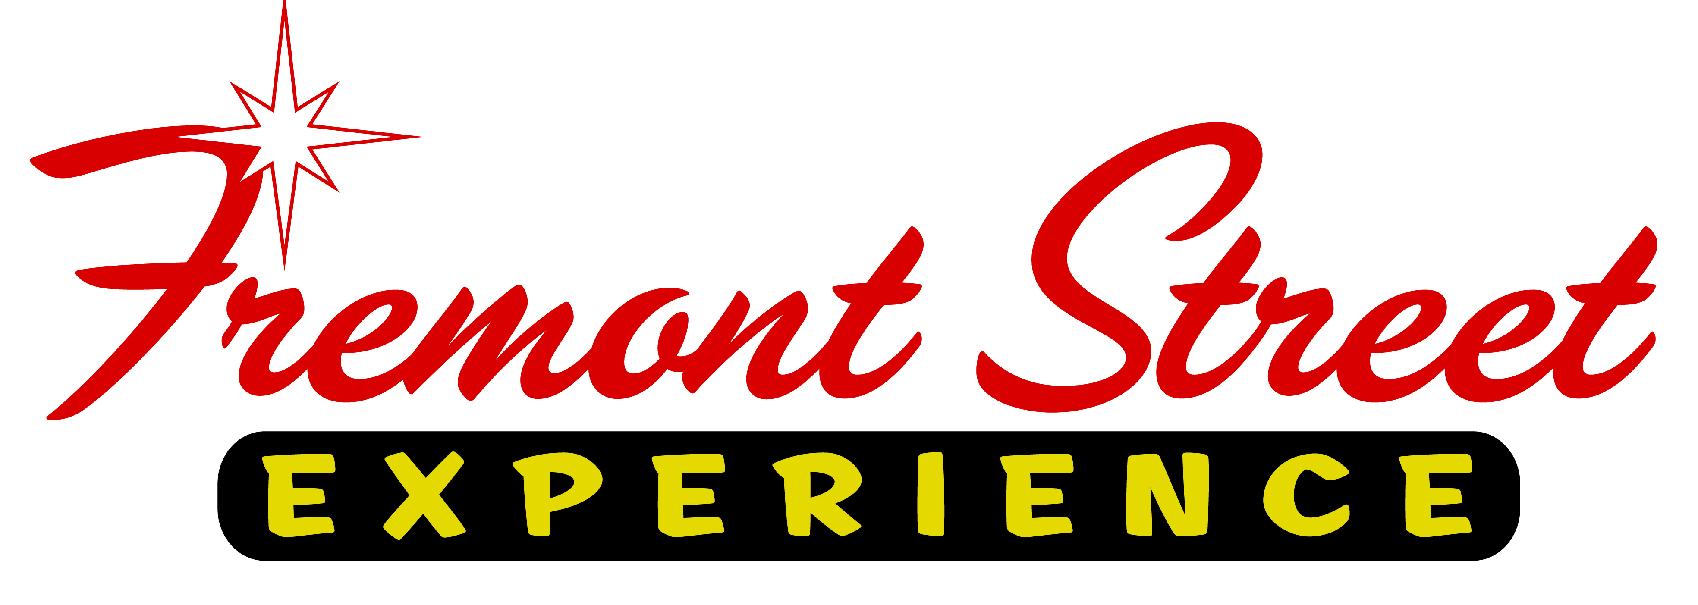
CELEBRATE FOURTH OF JULY WITH UFC INTERNATIONAL FIGHT WEEK™

Papa Roach, P.O.D. and Lit to Headline FREE Concert on Fremont Street Experience with Continuous Events throughout the Day on July 4

Las Vegas, Nev. (June 5, 2014) – Celebrate Fourth of July underneath the Viva Vision canopy with UFC International Fight Week™ and Fremont Street Experience’s Rock of Vegas summer concert series featuring rockers Papa Roach, P.O.D. and Lit. Downtown Las Vegas gets in on the UFC International Fight Week action as several events including an Ulti-man™ 5k run, meet-and-greets and autograph signings with UFC® fighters and Octagon Girls® and a special concert take over Fremont Street Experience.

The third annual UFC International Fight Week returns to Las Vegas from July 1-6 with something for everyone and unprecedented access to the largest gathering of UFC fighters ever. The weeklong celebration culminates with two HUGE fight cards that weekend in Las Vegas – UFC 175, presented by Bud Light® on Sat., July 5 and The Ultimate Fighter® Finale: TEAM EDGAR vs. TEAM PENN on Sun., July 6 both at Mandalay Bay Events Center.

While Fremont Street Experience will transform Downtown Las Vegas into the hottest place to be on Fourth of July featuring the free concert and a fireworks show displayed on the Viva Vision canopy screen, the UFC’s Fourth of July festivities during International Fight Week will be continuous throughout the day.

FRI., JULY 4th SCHEDULE OF EVENTS
More details available at www.UFC.com/FightWeek * All times PT

7:00-9:00 a.m. Ulti-man 5K Run featuring UFC FIT™ Stations
Hogs & Heifers, 201 N 3rd St, Las Vegas, NV 89101
Celebrate the Fourth of July by running or walking through the heart of Downtown Las Vegas. The event starts and finishes at Hogs & Heifers. Registration starts at 7 a.m. PT followed by UFC FIT-inspired warm-up with UFC women’s bantamweight Miesha Tate, UFC FIT Coach Mike Dolce and UFC GYM coaches at 7:30 a.m. Registration is $35 per participant (increases after June 9) and includes an official Ulti-man race t-shirt and medal. Register in advance at www.UFC.com/FightWeek.

9 a.m. & 1:00 p.m. 2014 World Soccer Tournament Viewing Party
Lagasse’s Stadium, 3325 S Las Vegas Blvd, Las Vegas, NV 89109
Fan can watch and cheer on teams, enjoy Q&A’s with fighters and play the newly launched EA SPORTS UFC video game.

3:00-5:00 p.m. UFC 175 Weigh-In
Mandalay Bay Events Center, 3950 S Las Vegas Blvd, Las Vegas, NV 89119
Just one day before UFC 175, fans can watch fighters step on the scale for official weigh-ins.

4:00 p.m. Lion Fight 16
The Pearl at the Palms, 4321 W Flamingo Rd, Las Vegas, NV 89103
Mixed martial arts fans can enjoy a full night of Muay Thai action.

5:30 p.m. UFC Tonight Special Edition
Mandalay Bay Events Center, 3950 S Las Vegas Blvd, Las Vegas, NV 89119
Following UFC 175 Weigh-ins fan can enjoy a special live taping of UFC Tonight.

6:00 p.m. The Art of Fighting Art Exhibit
The Gallery at 1217 on Main Street, Las Vegas, NV 89101
Experience mixed martial arts like never before at this exhibit of fight-related artwork headlined by contemporary urban artist Justin Bua, and featuring works from Octagon Girl Brittney Palmer, modern-day surrealist Brian Kirhagis, and the Fightland Photo Collection. Pieces will be available for public sale.

6:00-8:00 p.m. UFC Downtown
Golden Nugget, El Cortez Hotel & Casino and Hogs & Heifers in Downtown Las Vegas
Several locations in Downtown Las Vegas will host meet-and-greets and autograph signings with UFC fighters and Octagon Girls.

9:00 p.m. Free Concert featuring Papa Roach, POD and Lit
Fremont Street Experience, 3rd Street Stage
Papa Roach, POD and LIT will rock fans during a free concert as part of the Rock of Vegas summer concert series. Concert restricted to adults 18 years and older with proper ID.

Through the UFC Community Works® program, a portion of funds raised during the 2014 UFC International Fight Week will help support Three Square Food Bank, ONE DROP, The Gay and Lesbian Community Center of Southern Nevada and Boys & Girls Club of Southern Nevada.

UFC®175: WEIDMAN vs. MACHIDA will be available live on Pay-Per-View at 10 p.m. ET/7 p.m. PT on UFC.TV, iN DEMAND, DirecTV, DISH Network, Avail-TVN, and in Canada on BellTV, Shaw Communications, Sasktel, and Viewer’s Choice Canada for a suggested retail price of $44.99 US/$49.99 CAN for Standard Definition and $54.99 US/$59.99 CAN for High -Definition.

THE ULTIMATE FIGHTER FINALE: EDGAR vs. PENN will air live on FOX Sports 1 at 9 p.m. ET/6 p.m. PT Sunday, July 6, with the prelims kicking off the evening on FOX Sports 2 at 5 p.m. ET/2 p.m. PT.

Stay connected with UFC International Fight Week news on Facebook (www.Facebook.com/UFCFightWeek), Twitter and Instagram (@UFCFightWeek).

About Fremont Street Experience
Fremont Street Experience, a five-block entertainment district located in historic downtown Las Vegas features Viva Vision, the world’s largest video screen – 1,500 feet long, 90 feet wide and suspended 90 feet above the urban pedestrian mall. Viva Vision features nightly spectacular light and sounds shows with 12.5 million LED lights and a 550,000-watt sound system. Fremont Street Experience is a one-of-a-kind venue that includes free nightly concerts and entertainment on three stages. With direct pedestrian access to 8 casinos, more than 60 restaurants and specialty retail kiosks, Fremont Street Experience attracts more than 17 million annual visitors. Visit online at www.vegasexperience.com, Facebook: http://www.facebook.com/FSE89101 or Twitter: https://twitter.com/FSELV.

About the Ultimate Fighting Championship®
Owned and operated by Zuffa, LLC, the Ultimate Fighting Championship (UFC®) is the premier mixed martial arts (MMA) organization and largest pay-per-view event provider in the world. Headquartered in Las Vegas with offices in London, Toronto, Beijing, Singapore and Sao Paulo, UFC produces more than 40 live events annually that consistently sell out some of the most prestigious arenas around the globe. UFC programming is broadcast in over 145 countries to 800+ million TV households worldwide in 28 different languages. The UFC has a multi-year broadcast agreement with FOX in the U.S., which annually includes four live events broadcast on the FOX network, as well as The Ultimate Fighter® reality television show and thousands of hours of programming on FOX Sports 1 and FOX Sports 2. In 2014, UFC launched UFC FIGHT PASS™, a digital subscription service with exclusive live events, thousands of fights on-demand and original content. The UFC organization also licenses over 100 UFC GYM® locations, and owns UFC.TV® (offering live event broadcasts and video on-demand around the world), UFC FIT™ (an in-home fitness and nutrition program), UFC Magazine, and has a videogame franchise with EA SPORTS, UFC Fight Club®, UFC Fan Expo®, Octagon™ branded apparel, best-selling DVDs and Blu-rays and Topps Trading Cards. For more information, visit www.UFC.com and follow UFC at www.Facebook.com/UFC and on Twitter and Instagram: @UFC.

###

For more information, contact:

James Woodrow/Lauren Silverstein
Preferred Public Relations
702-254-5704
James@Preferredpublicrelations.com
Lauren@Preferredpublicrelations.com

