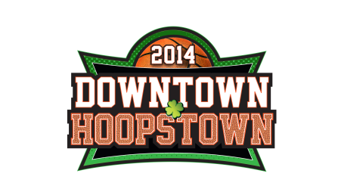
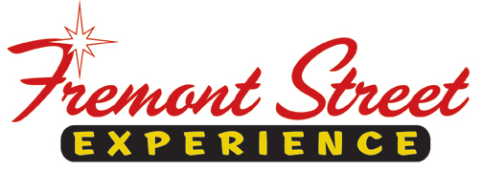

FOR IMMEDIATE RELEASE

Dribble Down to the 5th Annual Downtown Hoopstown
at Fremont Street Experience

Custom stage production show Hardwood Hotties
features American Idol Season 6 Finalist Haley Scarnato

Celebrate with basketball-themed events and attractions through April 8

Click to Tweet: http://ctt.ec/bM21a Dribble Down to the 5th Annual Downtown Hoopstown taking place through April 8 at @FSELV.

LAS VEGAS – March 5, 2014 – Fremont Street Experience invites college basketball fans to dribble down to the 5th Annual Downtown Hoopstown taking place through April 8. The four blocks underneath the Viva Vision canopy will be lined with college banners and flags as Fremont Street Experience transforms into the ultimate college basketball destination with special events that are sure to be a slam dunk including: nightly entertainment from the stage production show Hardwood Hotties featuring American Idol Season 6 Finalist Haley Scarnato, an interactive High Hoops Zone, the world’s largest NCAA bracket and a special basketball-themed show displayed on the 1,500 ft. Viva Vision canopy.

5th Annual Downtown Hoopstown Events/Attractions:

- Hardwood Hotties – The sexy, crowd pleasing, Hardwood Hotties are back, this time featuring American Idol Season 6 Finalist Haley Scarnato. The Hardwood Hotties will pump up the jams with songs such as Katy Perry’s “Roar,” Billy Idol’s “Rebel Yell” and Pussycat Dolls “When I Grow Up” as a high-flying aerialist soars above the stage. Hardwood Hotties is a custom stage production show created exclusively for Fremont Street Experience by Face Productions. Hardwood Hotties will perform on the 3rd Street Stage from 7-10 p.m. on the following dates: Mar. 2-5, 9-12, 18, 19, 21-26, Mar. 28 – Apr. 2, and Apr. 6-8.
- High Hoops Zone – The High Hoops Zone will return, giving fans a chance to test their skills and challenge their friends to basketball shoot-outs featuring 20-, 25-, and 30-foot basketball hoops for only $1 dollar per shot.
- Worlds Largest NCAA Bracket – Bracketology soars to new heights with the world’s largest NCAA bracket will be displayed on the 1,500-foot long Viva Vision canopy and updated daily Mar.18 – Apr. 8.
- Viva Vision Show – Each night beginning at dusk the Viva Vision canopy will feature a special basketball-themed Viva Vision show custom synced with bouncing basketballs, slam dunks and more, to the music of “Are You Ready For This.”

The 5th Annual Downtown Hoopstown is sponsored by Crown Royal.

About Fremont Street Experience
Fremont Street Experience, a five-block entertainment district located in historic downtown Las Vegas features Viva Vision, the world’s largest video screen - 1,500 feet long, 90 feet wide and suspended 90 feet above the urban pedestrian mall. Viva Vision features nightly spectacular light and sounds shows with 12.5 million LED lights and a 550,000-watt sound system. Fremont Street Experience is a one-of-a-kind venue that includes free nightly concerts and entertainment on three stages. With direct pedestrian access to 8 casinos, more than 60 restaurants and specialty retail kiosks, Fremont Street Experience attracts over 17 million annual visitors. Visit online at www.vegasexperience.com, Facebook: http://www.facebook.com/FSE89101 or Twitter: https://twitter.com/FSELV.

###
MEDIA CONTACT:
Lauren Silverstein/James Woodrow
Preferred Public Relations
702-254-5704
Lauren@preferredpublicrelations
James@preferredpublicrelations

